**Business Report on**

***Time Series Forecasting***

***Submitted to***



**Great Learning Olympus**

***Prepared by***

**Mrinmoy Majumdar**

**June-D Batch**

**Post Graduate Program in Data Science & Business Analytics**

**From**



UT Austin

**February, 2022**

TABLE OF CONTENT

**1.**Read the data as an appropriate Time Series data and plot the data………….4

**2.**Perform appropriate Exploratory Data Analysis to understand the data and also perform decomposition…………………………………………………….7

**3.** Split the data into training and test. The test data should start in 1991……23

###### **4.**Build all the exponential smoothing models on the training data and evaluate the model using RMSE on the test data. Other additional models such as regression, naïve forecast models, simple average models, moving average models should also be built on the training data and check the performance on the test data using RMSE……………………………………………………...26

**5.** Check for the stationarity of the data on which the model is being built on using appropriate statistical tests and also mention the hypothesis for the statistical test. If the data is found to be non-stationary, take appropriate steps to make it stationary. Check the new data for stationarity and comment………...47

6. Build an automated version of the ARIMA/SARIMA model in which the parameters are selected using the lowest Akaike Information Criteria (AIC) on the training data and evaluate this model on the test data using RMSE……….51

7. Build ARIMA/SARIMA models based on the cut-off points of ACF and PACF on the training data and evaluate this model on the test data ………….69

8. Build a table with all the models built along with their corresponding parameters and the respective RMSE values on the test data………………….82

9. Based on the model-building exercise, build the most optimum model(s) on the complete data and predict 12 months into the future with appropriate confidence intervals/bands…………………………………………………….84

10. Comment on the model thus built and report your findings and suggest the measures that the company should be taking for future sales………………….87

**LIST OF FIGURES**

|  |  |
| --- | --- |
| **Images** | **Page No** |
| **Datatype check** | **5** |
| **Time series plot** | **6** |
| **Null value check** | **8** |
| **Quarterly sales plot** | **13** |
| **Box plot** | **14** |
| **Month plot** | **15** |
| **Yearly plot** | **16** |
| **Daily plot** | **19** |
| **Decade plot** | **20** |
| **Additive decomposition** | **21** |
| **Multiplicative decomposition** | **22** |
| **Train test model graph** | **24** |
| **SES base model plot** | **27** |
| **DES base model plot** | **31** |
| **TES base model plot** | **33** |
| **Stationarity plot** | **48** |
| **ACF plot** | **56** |
| **PACF plot** | **57** |
| **Model summary** | **59** |
| **Model diagnostic plot** | **64** |
| **Seasonal difference plot** | **74** |
| **Prediction plot** | **85** |
| **Forecasting plot** | **86** |

**LIST OF TABLES**

|  |  |
| --- | --- |
| Table 1 | 4 |
| Table 2 | 4 |
| Table 3 | 5 |
| Table 4 | 6 |
| Table 5 | 10 |
| Table 6 | 10 |
| Table 7 | 12 |
| Table 8 | 12 |
| Table 9 | 27 |
| Table 10 | 28 |
| Table 11 | 28 |
| Table 12 | 29 |

**Problem Statement:**

For this particular assignment, the data of different types of wine sales in the 20th century is to be analysed. Both of these data are from the same company but of different wines. As an analyst in the ABC Estate Wines, you are tasked to analyse and forecast Wine Sales in the 20th century.

**Q1. Read the data as an appropriate Time Series data and plot the data.**

Displaying sparkling wine type data:

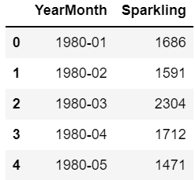

**Table 1: Top 5 rows of sparkling wine type data Frame**

Displaying rose wine type data:

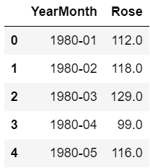

**Table 2: Rose wine type data frame with top 5 rows**

Checking datatypes for both datasets, we find that “YearMonth” column is not seen as a date object, so we provide inputs to tell pandas that we are working with time series data and then only the time series reference is identified. Time series reference is also made the index.

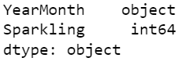

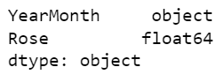

**Image 1: Datatypes of original Sparkling and Rose datasets**

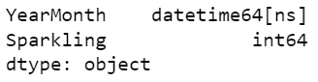

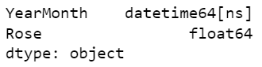

**Image 2: Datatypes of Sparkling and Rose datasets post conversion to time series**

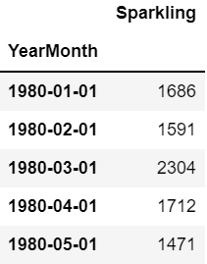

**Table 3: Sparkling time series dataset**

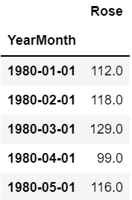

**Table 4: Rose time series dataset**

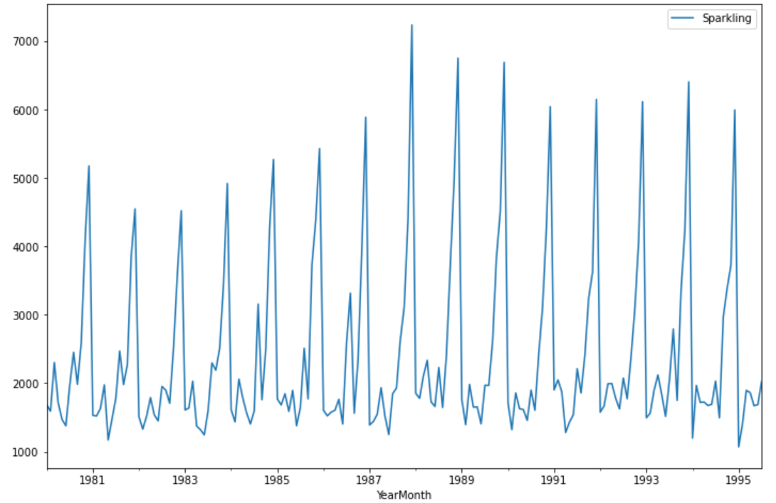

**Image 3: Time series plot of Sparkling data**

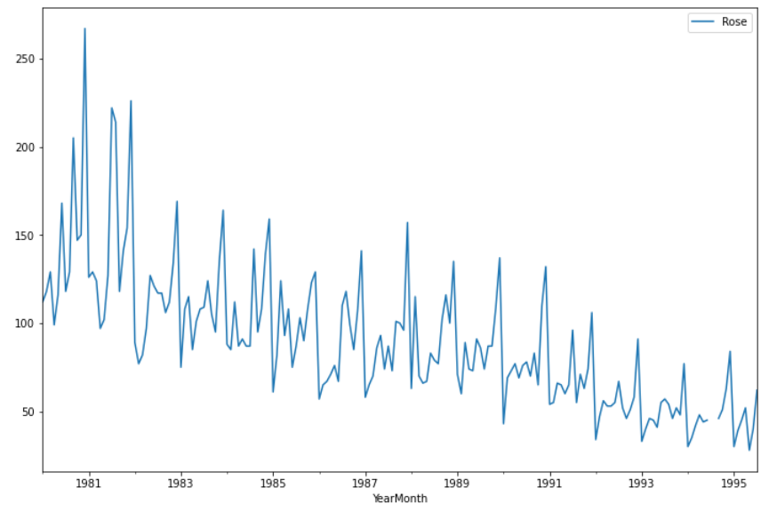

**Image 4: Time series plot of Rose data**

Inferences-

* Sparkling and rose type wine sales data is available from the year 1980 to 1995 as seen from the plots.
* Time series for sparkling dataset shows seasonality but the trend is not consistent. There is a significant upward and downward trend throughout the entire year span which signifies sales peak at a certain period of time. Highest sales were observed in 1988 as it displays the highest peak.
* Rose wine type time series shows seasonality with downward trend. Sales peaked in the year 1981 and then went downhill with few peaks in every year but not as significant as the highest peak.
* A break is observed in the year 1994 for rose data time series which needs to be inspected.
* It can be concluded from both the plots that sparkling wine is more preferred by customers as compared to rose wine.

**Q2. Perform appropriate Exploratory Data Analysis to understand the data and also perform decomposition.**

## Basic EDA:

* Checking shape and information of Rose and Sparkling data Frame

(187,1) – Both the data set contains 187 observations of data and 1 variable.

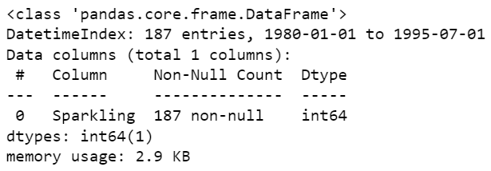

**Image 5: Information on Sparkling dataset**

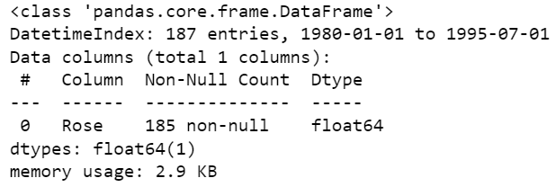

**Image 6: Information on Rose dataset**

### Majority of the Sparkling data has 187 instances with 1 attribute – 1 variable of integer type.

Rose data has 185 instances with 1 variable of floating type attribute.

* Check the presence of missing values

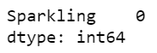

**Image 7: Checking null values in Sparkling data**

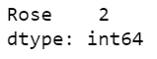

**Image 8: Checking null values in Rose data**

### There are no null values in Sparkling column. But there is presence of 2 null values in Rose column.

Next, we can interpolate the missing values. The function, interpolate () of pandas’ library is used to interpolate the missing values. We use a linear interpolation which draws a straight line between available data, on the first day of the month and fills in values at the chosen frequency from this line.

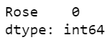

**Image 9: Null value check post interpolation in Rose data**

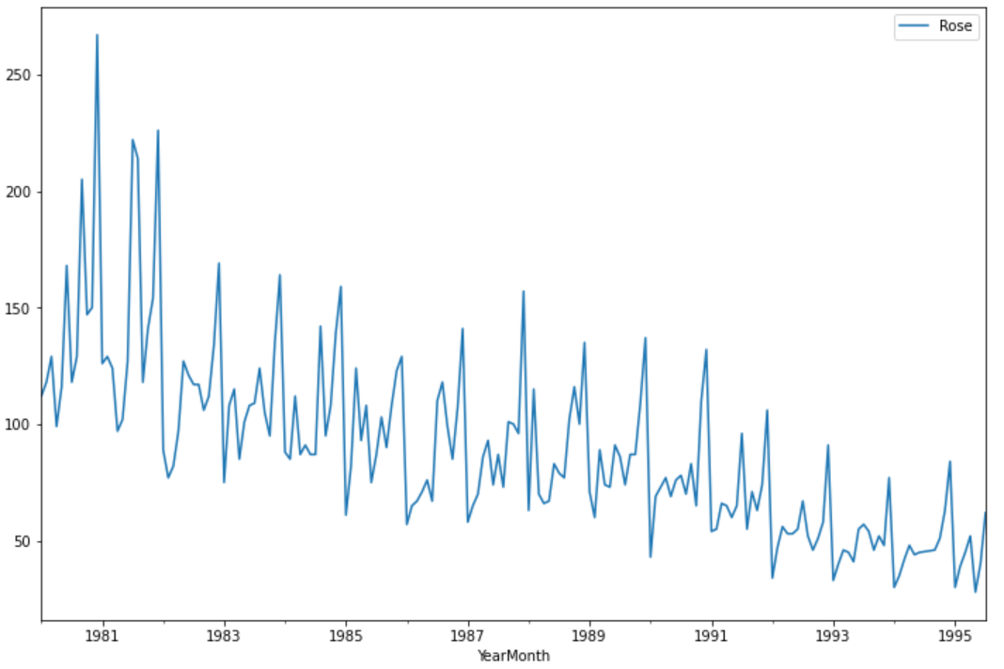

**Image 10: Time series interpolated plot of Rose data**

* Checking summary of Rose and Sparkling Data frames

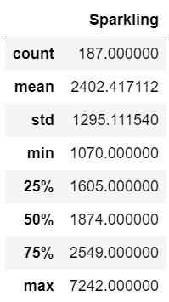

**Table 5: Description of Sparkling dataset**

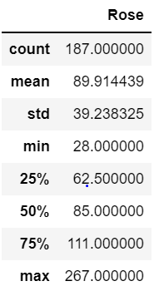

**Table 6: Description of Rose dataset**

Looking at the 5-point summary of both datasets, sparkling wine sold maximum 7242 units whereas rose wine sold highest 267 units. The minimum units sold for sparkling wine is 1070 units which is quite high compared to 28 units for rose wine. Both the datasets do not seem to be normally distributed as the difference between mean and median values is significant.

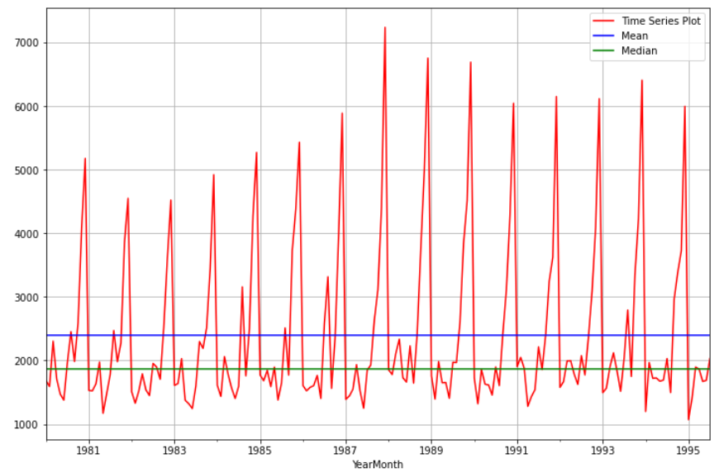

**Image 11: Time series plot of sparkling data with central tendencies**

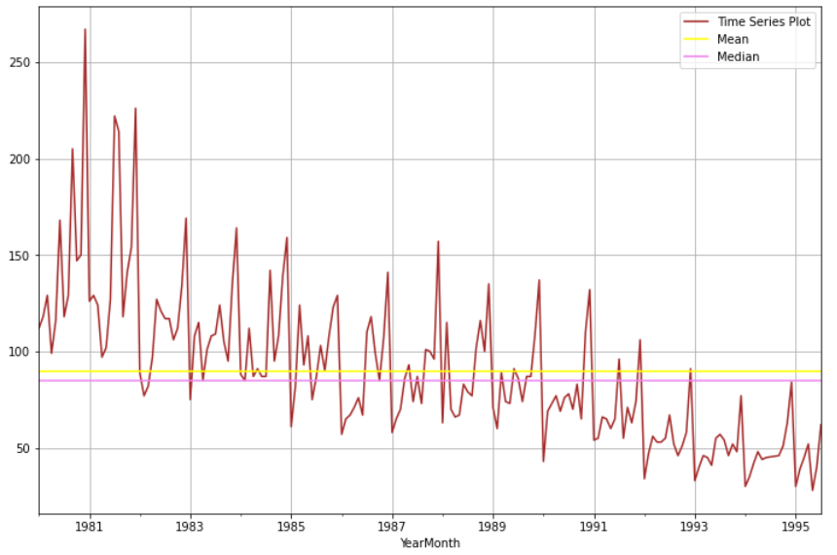

**Image 12: Time series plot of rose data with central tendencies**

Mean and median lines in rose plot are quite close to each other as compared to sparkling plot which indicates normal distribution for rose dataset.

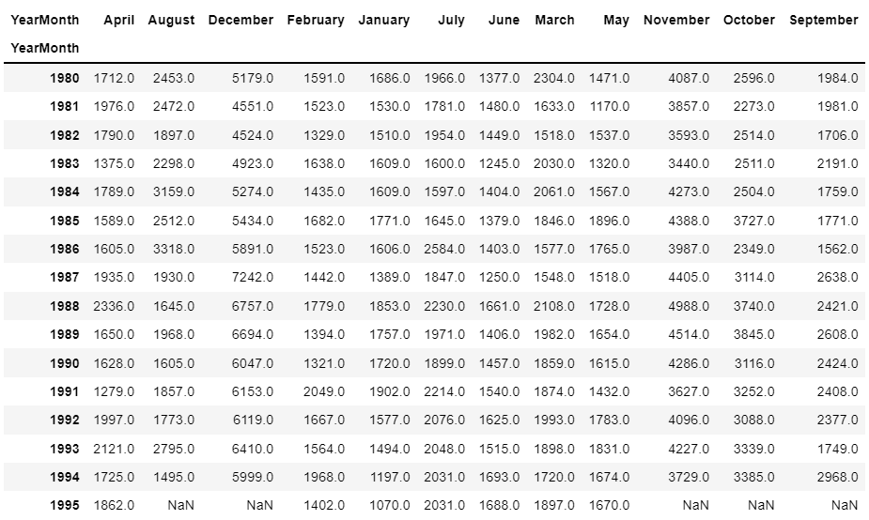

**Table 7: Sparkling sales across years month-wise**

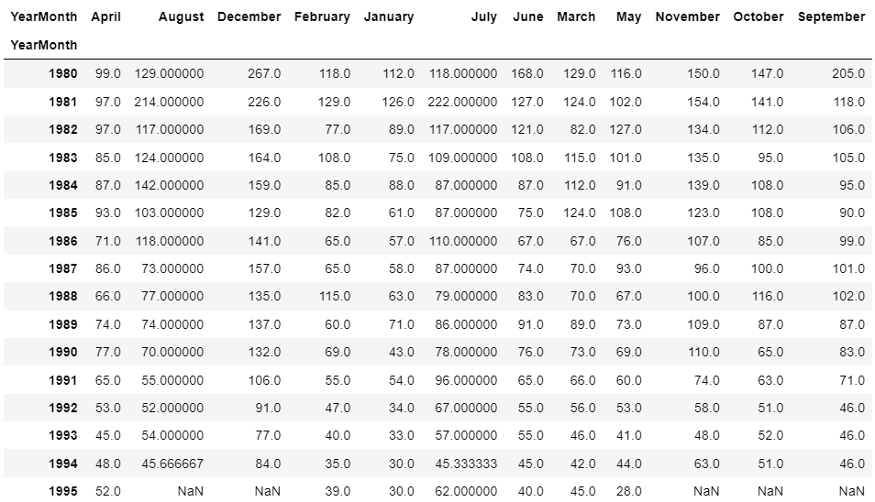

**Table 8: Rose sales across years month-wise**

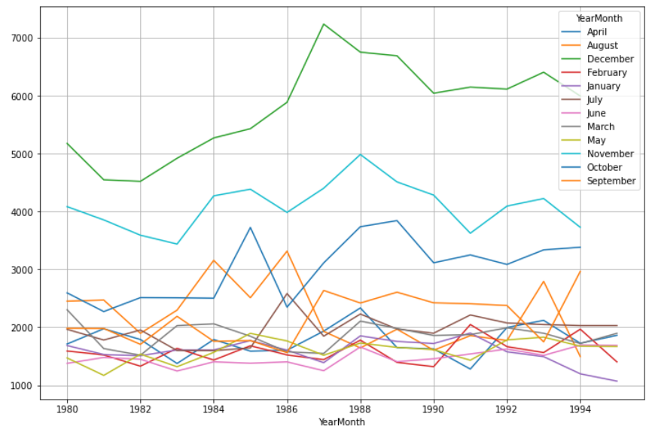

**Image 13: Quarterly sales plot of Sparkling wine**

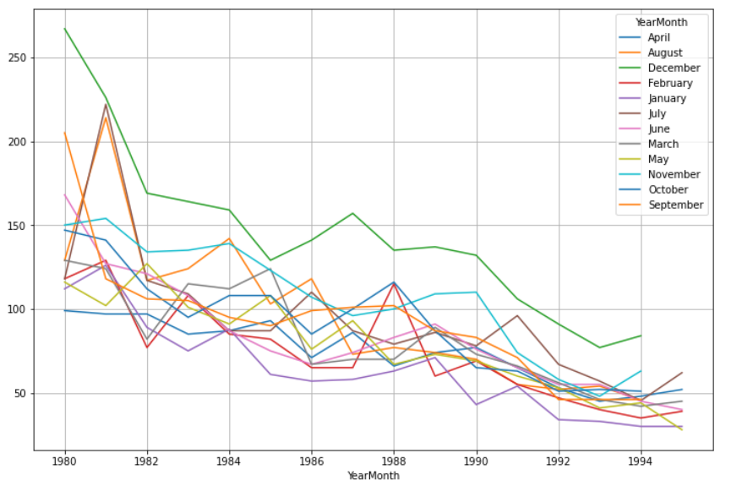

**Image 14: Quarterly sales plot of Rose wine**

For the year 1995, August to December month rose and sparkling wine sales have not been recorded as indicated by Nan values.

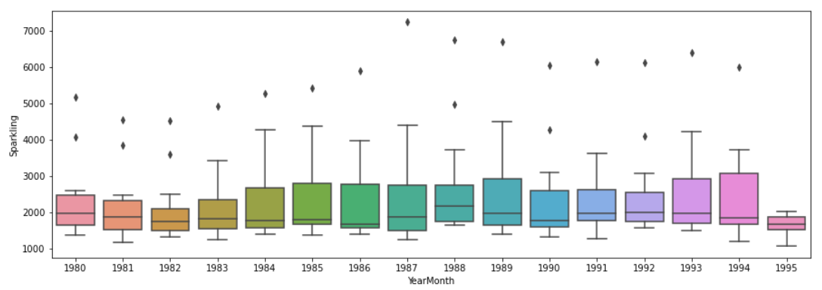

**Image 15: Year on year boxplot of Sparkling wine**

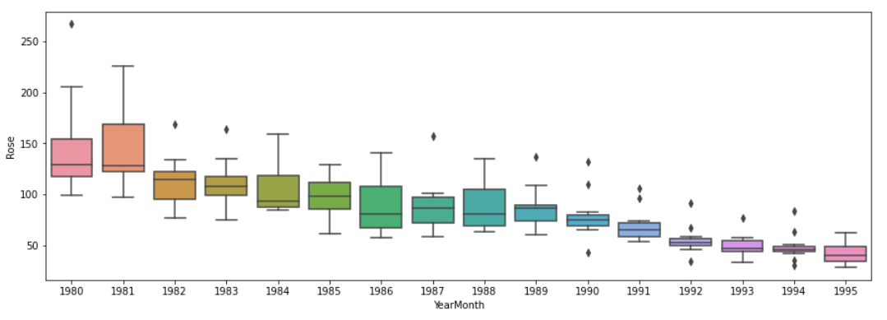

**Image 16: Year on year boxplot of Rose wine**

As we got to know from the Time Series plot, the boxplots over here also indicates a measure of trend being present. Also, we see that the sales of Sparkling and Rose wine has some outliers for certain years.

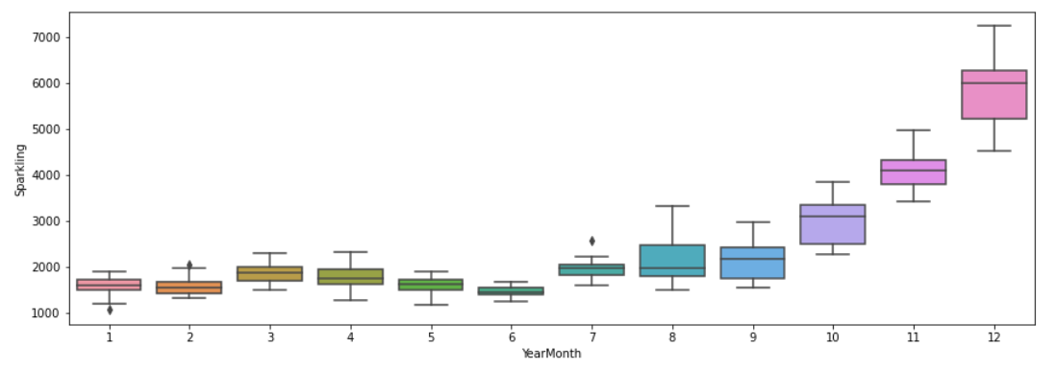

**Image 17: Monthly boxplot of Sparkling wine**

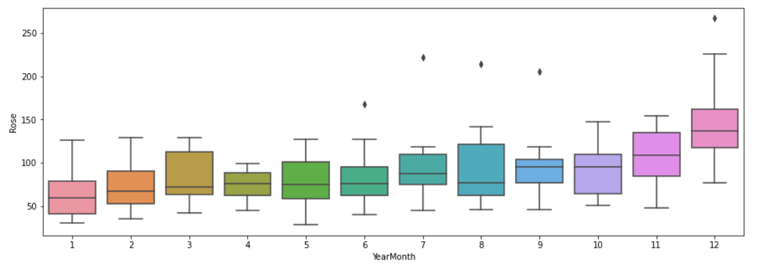

**Image 18: Monthly boxplot of Rose wine**

The boxplots for the monthly sales of sparkling and rose wine for different years does not show many outliers as compared to yearly one.

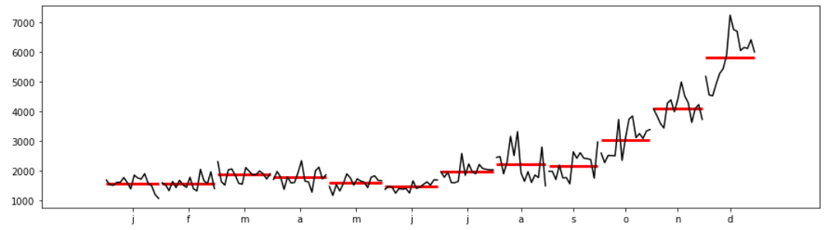

**Image 19: Month plot of Sparkling wine time series**

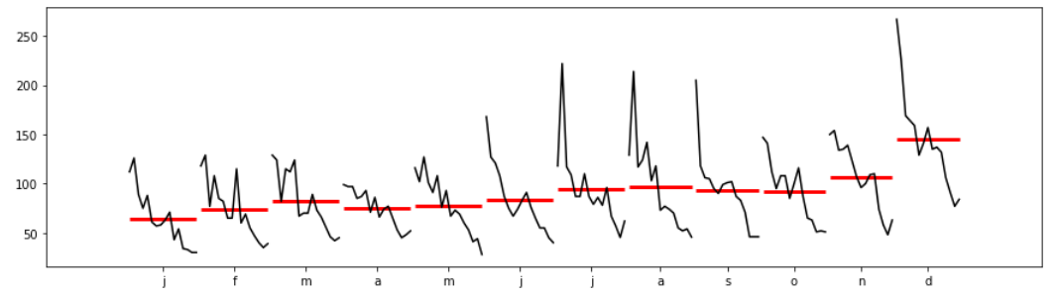

**Image 20: Month plot of Rose wine time series**

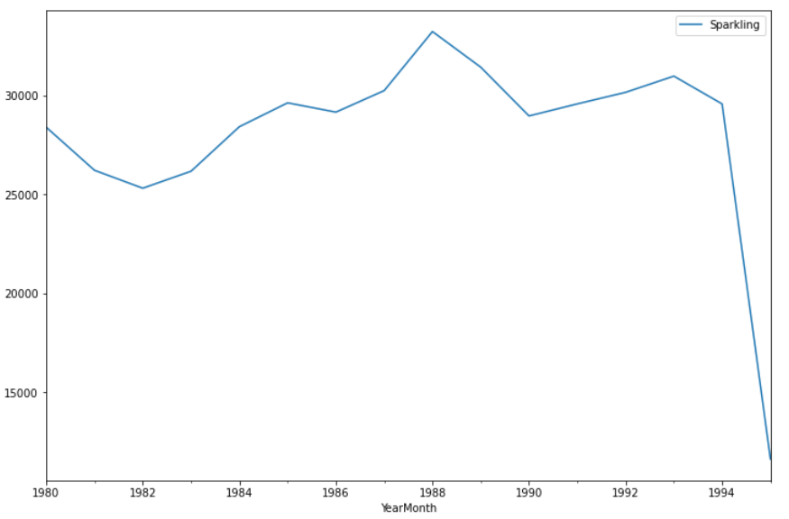

**Image 21: Yearly sum plot of Sparkling wine**

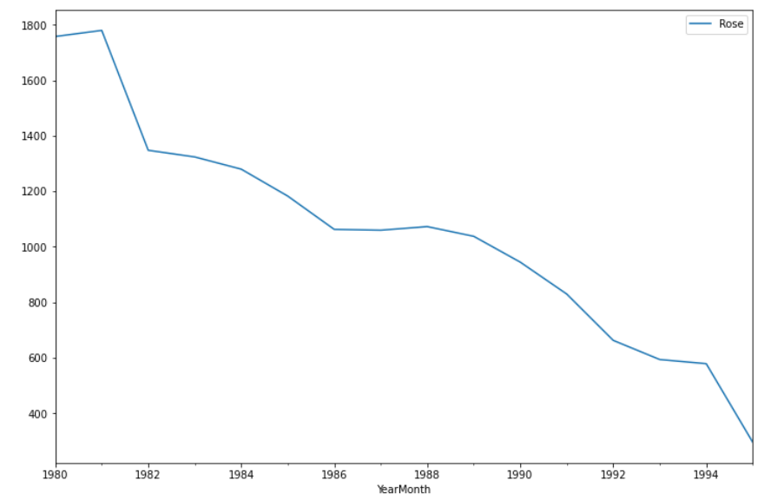

**Image 22: Yearly sum plot of Rose wine**

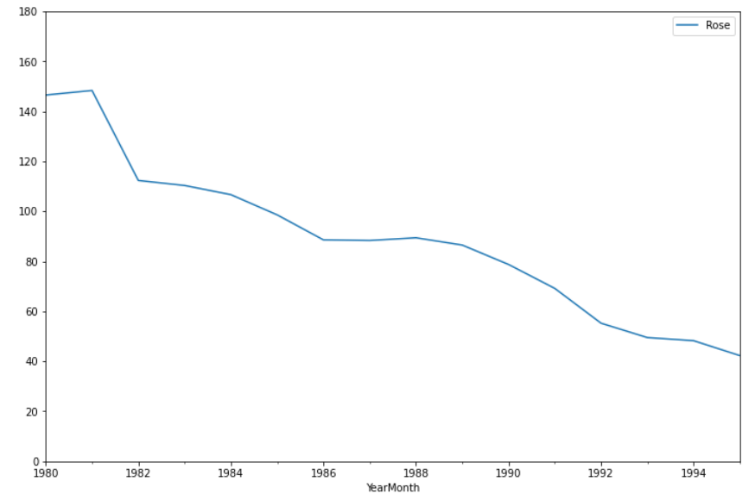

**Image 23: Yearly mean plot of Rose wine**

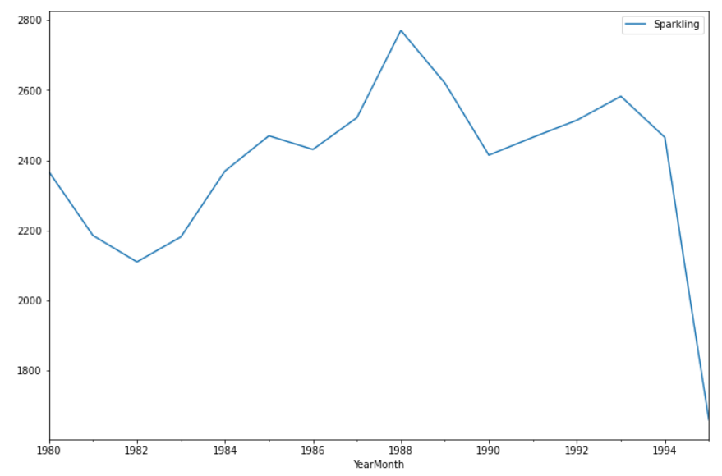

**Image 24: Yearly mean plot of Sparkling wine**

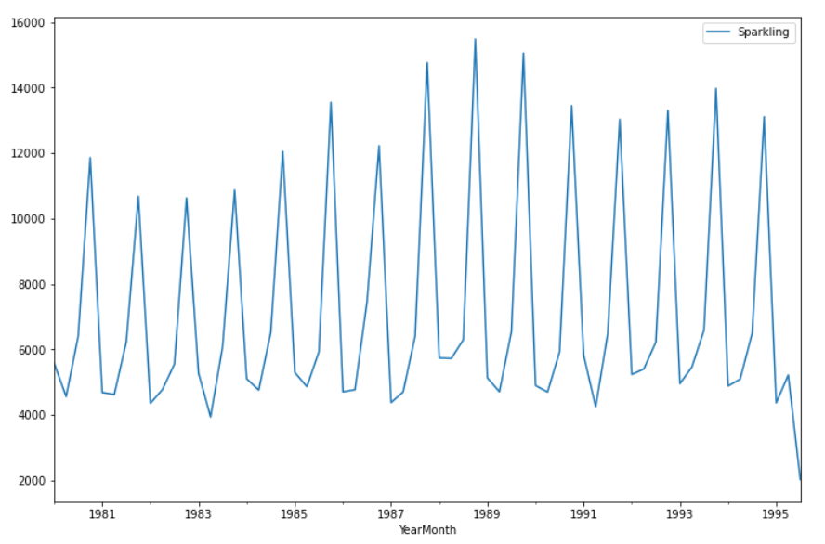

**Image 25: Quarterly plot of Sparkling wine**

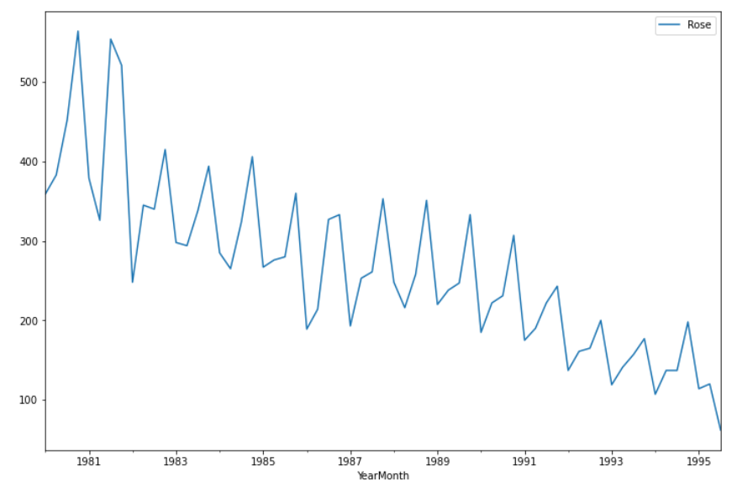

**Image 26: Quarterly plot of Rose wine**

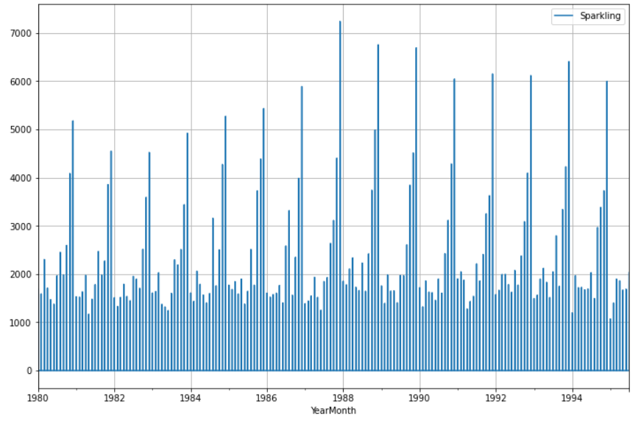

**Image 27: Daily plot of Sparkling wine**

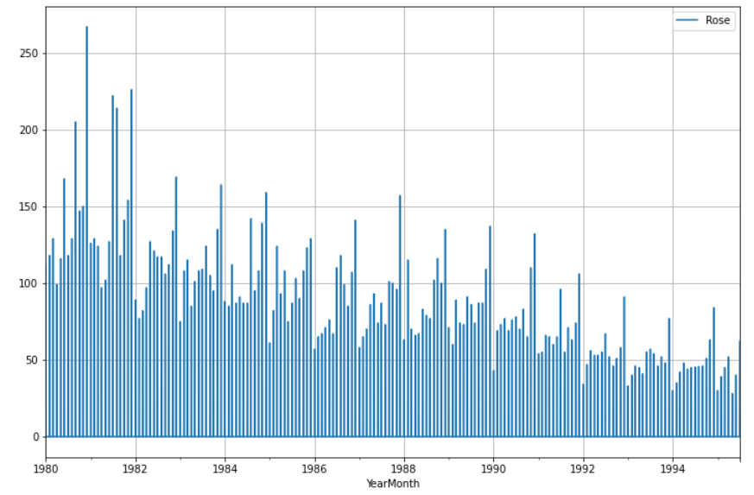

**Image 28: Daily plot of Rose wine**

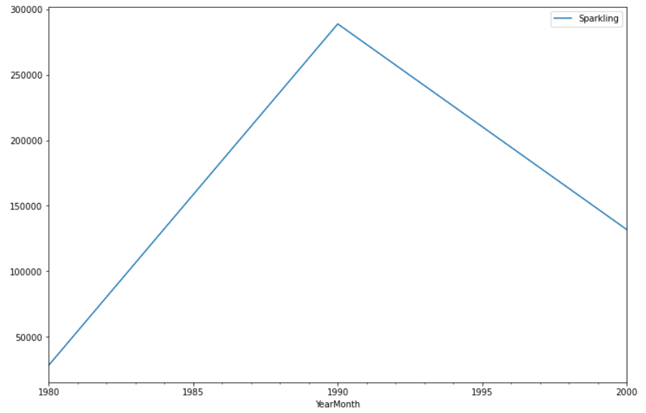

**Image 29: Decade plot of Sparkling wine**

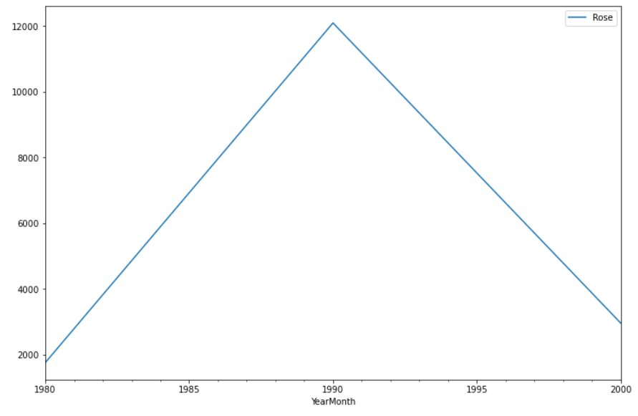

**Image 30: Decade plot of Rose wine**

Insights-

* The resampled yearly or annual series of both the datasets have smoothened out the seasonality and have only been able to capture the year-on-year trend where there was.
* We see that the year-on-year quarterly series represents the year-on-year monthly series. The quarterly series is able to catch the seasonality in the data.
* The daily graph fails to give us a proper understanding of our data. Thus, resampling the data to intervals where a number of observations are 0 is not a good idea as that does not give us an understanding of the performance of the time series. To get a very high-level overview of the trend of the Time Series Data (if Trend is present) can be understood by resampling the data keeping the intervals very large.
* If we take the resampling period to be 10 years or a decade, we see that the seasonality present has been smoothed over and it is only giving an estimate of the trend.

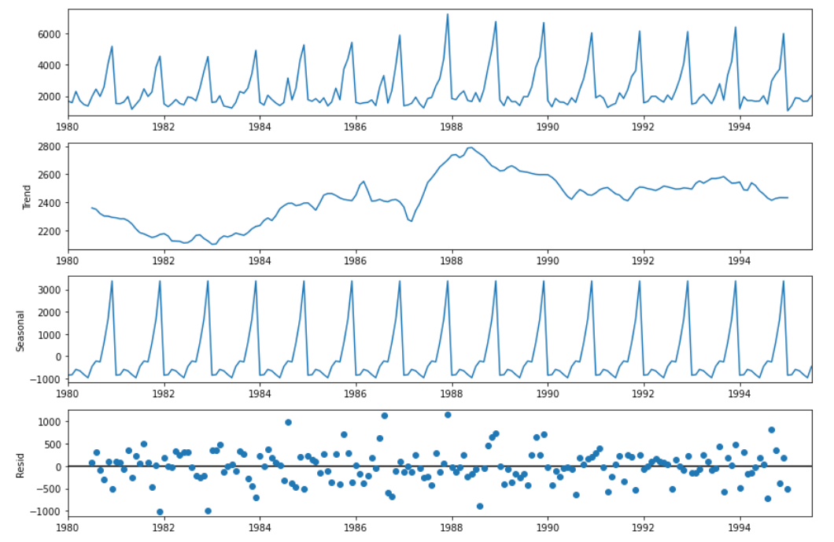

**Image 31: Additive decomposition of sparkling data**

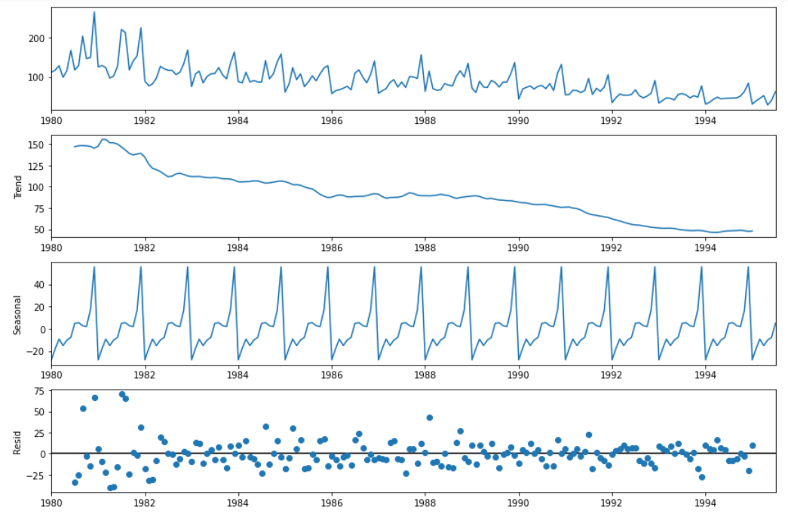

**Image 32: Additive decomposition of rose data**

As per the 'additive' decomposition, we see that there is a pronounced trend in the earlier years of the data. There is a seasonality as well.

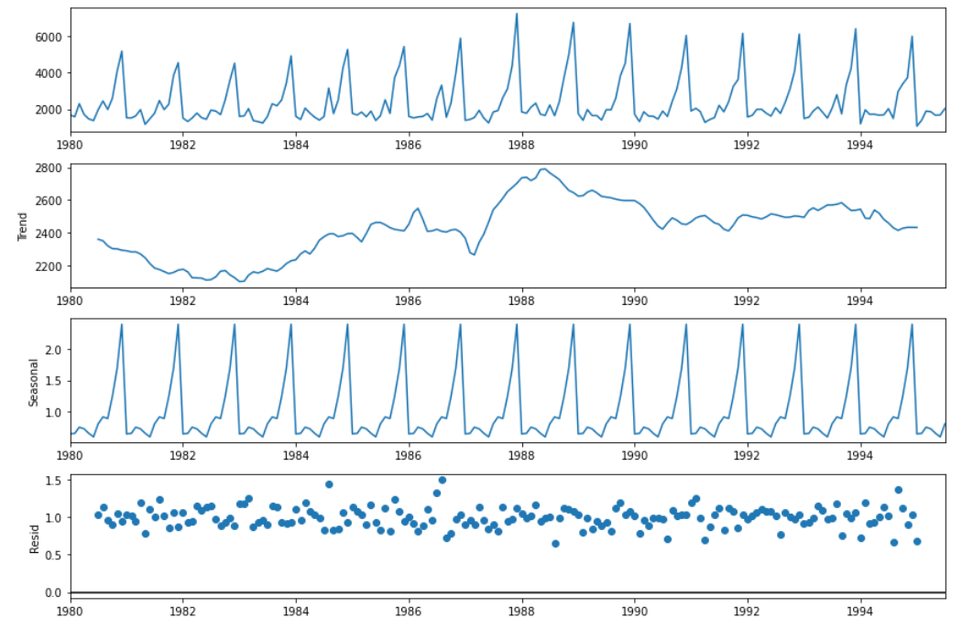

**Image 33: Multiplicative decomposition of sparkling data**

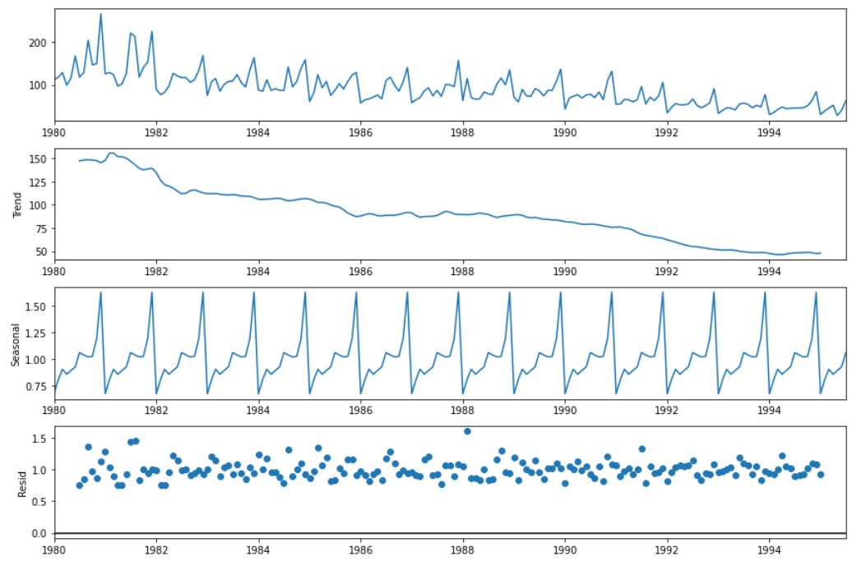

**Image 34: Multiplicative decomposition of rose data**

**Q3. Split the data into training and test. The test data should start in 1991.**

##### The sparkling and wine datasets are split individually into training and testing sets. The shape of both the datasets for training and testing sets are (132,1) and (55,1). It is difficult to predict the future observations if such an instance has not happened in the past. From our train-test split we are predicting likewise behaviour as compared to the past years.

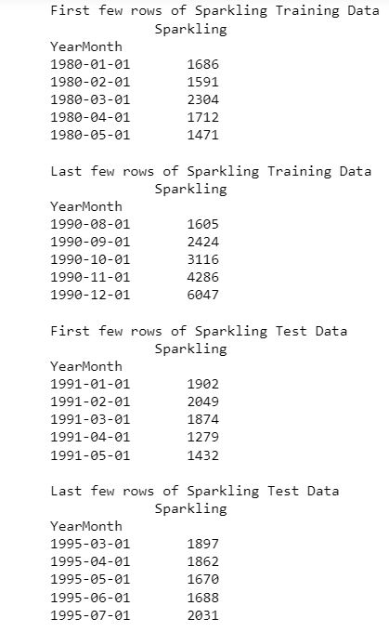

**Image 35: Displaying train-test rows of sparkling data**

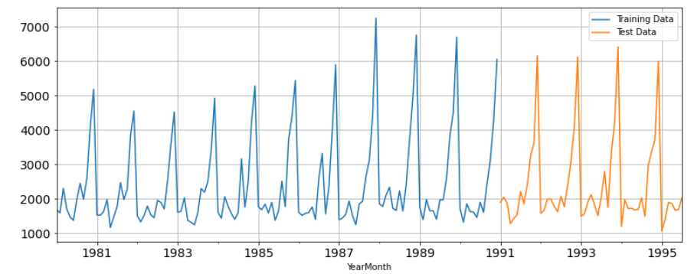

**Image 36: Train-test plot of sparkling data**

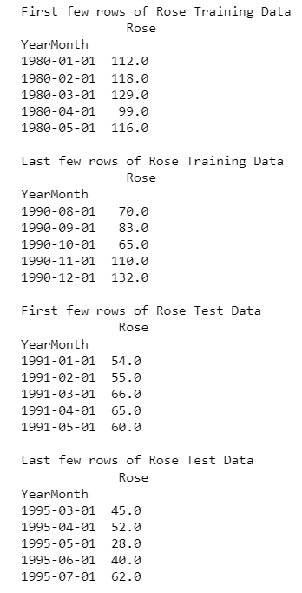

**Image 37: Rose data with train-test records**

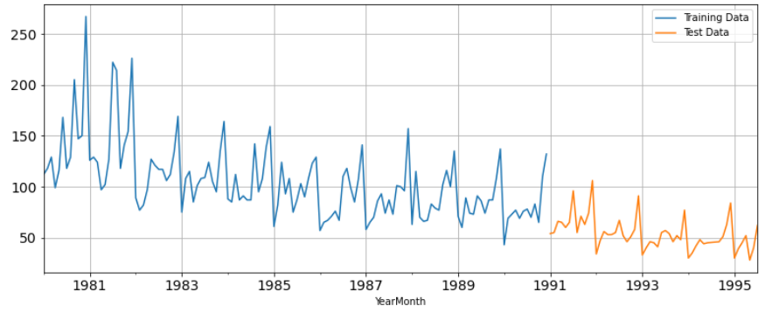

**Image 38: Train-test graphical representation of rose data**

**Q4. Build all the exponential smoothing models on the training data and evaluate the model using RMSE on the test data. Other additional models such as regression, naïve forecast models, simple average models, moving average models should also be built on the training data and check the performance on the test data using RMSE.**

##### Exponential smoothing methods consist of flattening time series data. Exponential smoothing averages or exponentially weighted moving averages consist of forecast based on previous periods data with exponentially declining influence on the older observations. Exponential smoothing methods consist of special case exponential moving with notation ETS (Error, Trend, Seasonality) where each can be none(N), additive (N), additive damped (Ad), Multiplicative (M) or multiplicative damped (Md). One or more parameters control how fast the weights decay. These parameters have values between 0 and 1.

### SES – ETS (A, N, N) - Simple Exponential Smoothing with additive errors

### The simplest of the exponentially smoothing methods is naturally called simple exponential smoothing (SES). This method is suitable for forecasting data with no clear trend or seasonal pattern.

In Single ES, the forecast at time (t + 1) is given by Winters,1960

* Ft+1=αYt+(1−α) Ft

Parameter α is called the smoothing constant and its value lies between 0 and 1. Since the model uses only one smoothing constant, it is called Single Exponential Smoothing.

SimpleExpSmoothing class must be instantiated and passed the training data.

The fit () function is then called providing the fit configuration, the alpha value and smoothing level. If this is omitted or set to None, the model will automatically optimize the value.

Parameter for sparkling dataset:

{'smoothing_level': 0.04960659884563118,'smoothing_trend': nan,'smoothing_seasonal': nan,'damping_trend': nan,'initial_level': 1818.5047543457245,'initial_trend': nan,'initial_seasons': array ([], dtype=float64), 'use_boxcox': False, 'lamda': None, 'remove_bias': False}

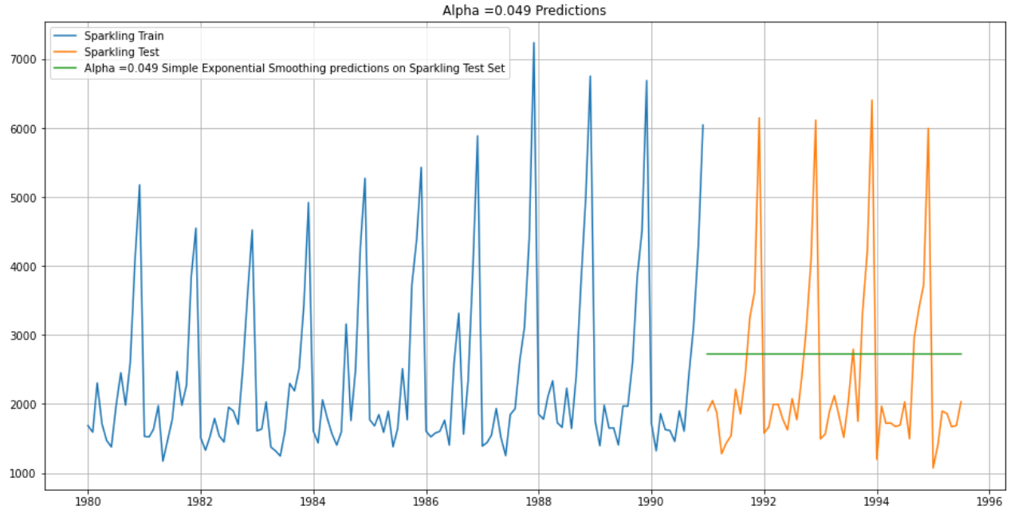

**Image 39: SES base model plot for Sparkling data**

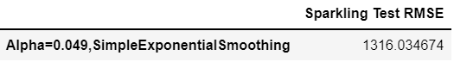

**Table 9: RMSE value for SES sparkling data**

Inference- Root mean squared error value is very high for base model of simple exponential smoothing, need to compare with tuned models or alternative models for better results.

#### We will set different alpha values. The higher the alpha value more weightage is given to the more recent observation. That means, what happened recently will happen again. We will run a loop with different alpha values to understand which particular value works best for alpha on the test set.

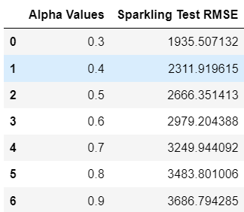

**Table 10: Optimum alpha values for SES**

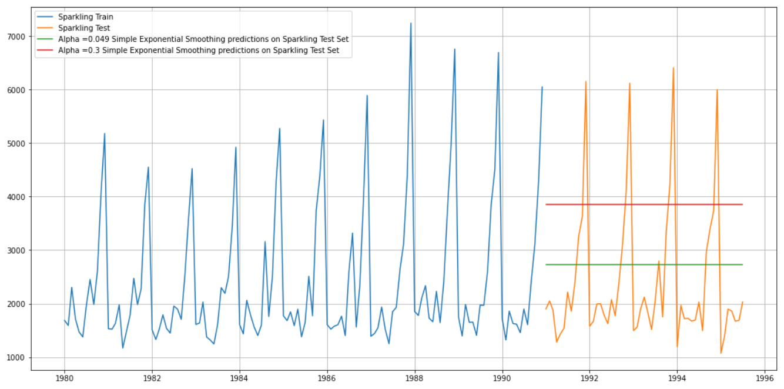

**Image 40: SES optimum and base model plot for Sparkling data**

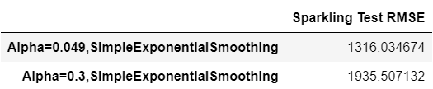

**Table 11: Optimum and base RMSE values for SES**

Inference- There is no improvement in error value after selecting optimum alpha values, so the base model of simple exponential smoothing is the better choice for sparkling wine.

Parameter for rose dataset:

{'smoothing_level': 0.09874995336438987,'smoothing_trend': nan,'smoothing_seasonal': nan, ‘damping_trend': nan,'initial_level': 134.38681121931316,'initial_trend': nan,'initial_seasons': array ([], dtype=float64),'use_boxcox': False,'lamda': None,'remove_bias': False}

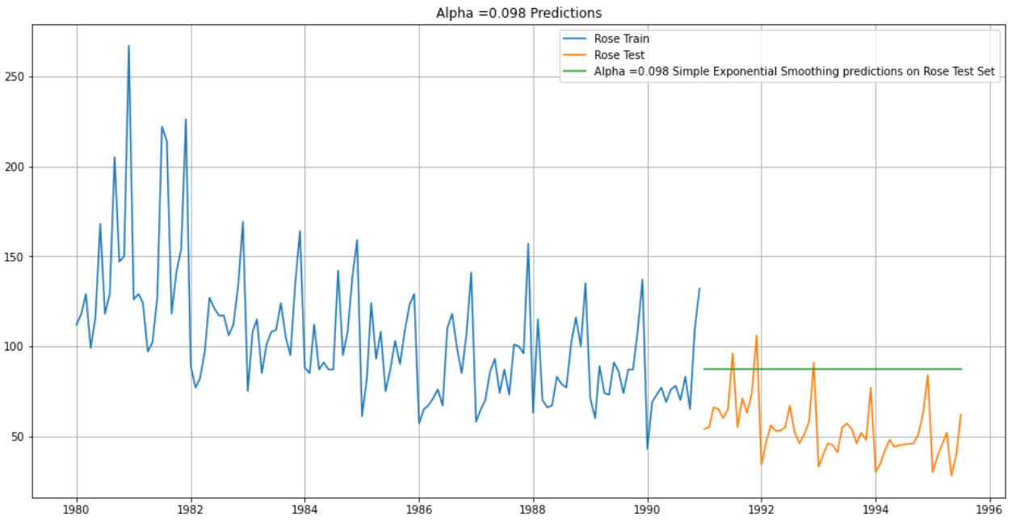

**Image 41: SES base model plot for Rose data**

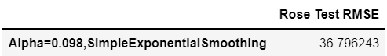

**Table 12: RMSE value for SES rose data**

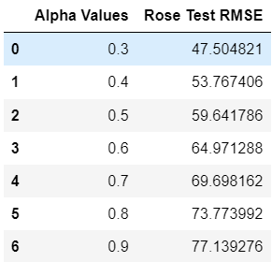

**Table 13: Optimum alpha values for SES rose data**

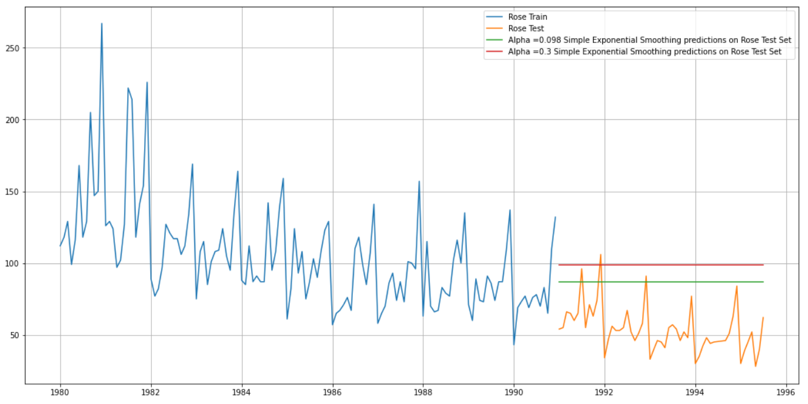

**Image 42: SES optimum model plot for Rose data**

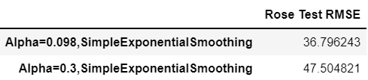

**Table 14: Optimum RMSE values for SES rose data**

Inferences: RMSE values are reduced to a considerable extent as compared to sparkling wine but the smoothing constant line do not pass through all the peaks of test data pattern which indicates the base or optimum model may not be a good factor for predicting future sales.

## Holt – ETS (A, A, N) - Holt's linear method with additive errors

Double Exponential Smoothing uses two equations to forecast future values of the time series, one for forecasting the short-term average value or level and the other for capturing the trend.

* Intercept or Level equation, Lt is given by: Lt=αYt+(1−α) Ft
* Trend equation is given by Tt=β(Lt−Lt−1) + (1−β) Tt−1

Here, α and β are the smoothing constants for level and trend, respectively,

* 0 < α < 1 and 0 < β < 1.

The forecast at time t + 1 is given by

* Ft+1=Lt+Tt
* Ft+n =Lt+ nTt

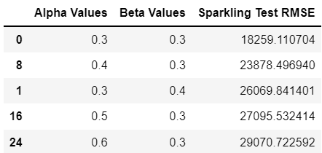

**Table 15: Optimum alpha values for DES Sparkling data**

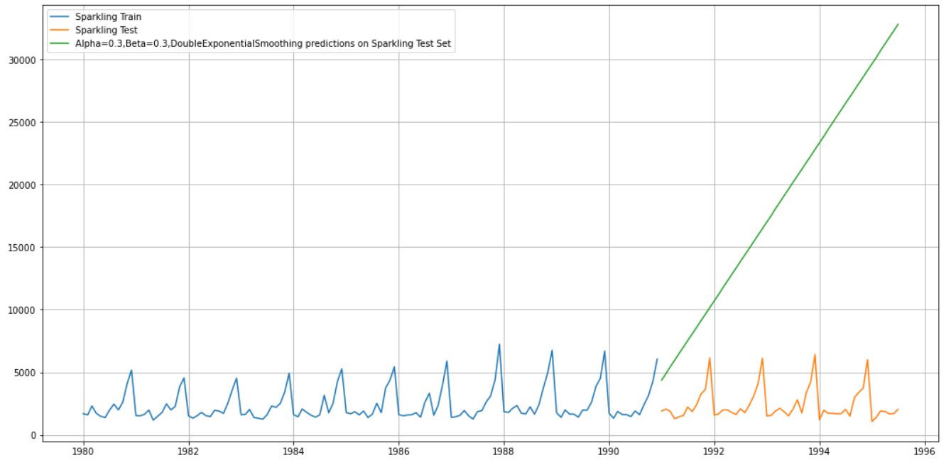

**Image 43: DES optimum model plot for Sparkling data**

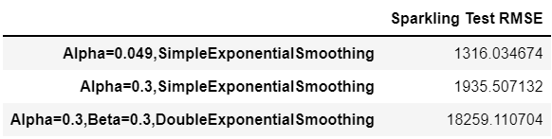

**Table 16: Optimum RMSE values for DES Sparkling data**

Inferences**-** Here, we see that the Double Exponential Smoothing has actually not done that well when compared to the Simple Exponential Smoothing for sparkling wine despite the fact that the Double Exponential Smoothing model has picked up the trend component as well. RMSE values also seem to suggest the same notion.

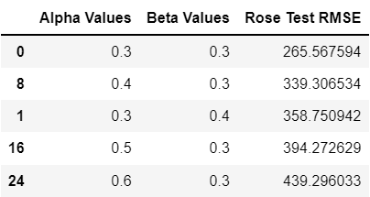

**Table 17: DES optimal alpha-beta values for rose data**

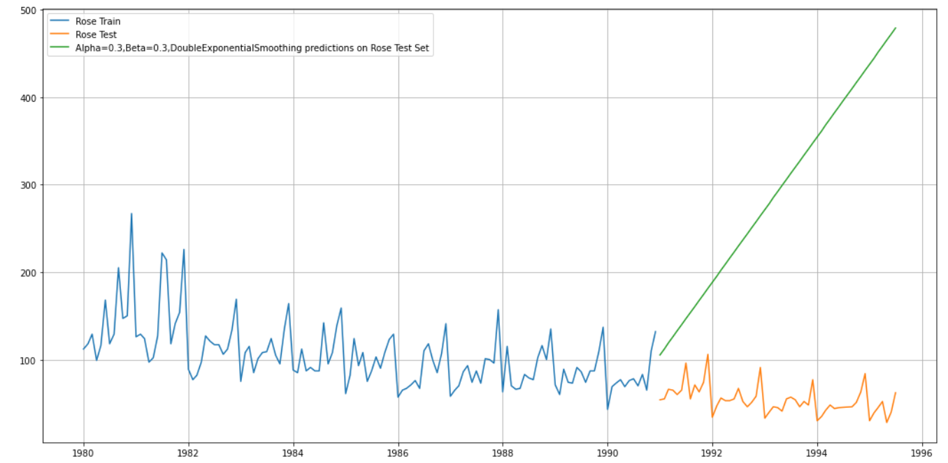

**Image 44: DES plot for rose wine**

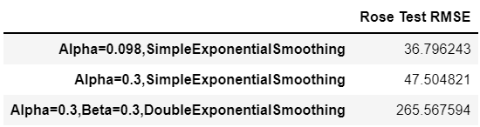

**Table 18: DES optimal RMSE values for rose data**

Inference**-** Increase in error value from the simple exponential smoothing model signifies choosing this model for rose wine sales may not be the best idea though the plot seems to indicate an increase in sales. Double exponential smoothing is picking up the trend component along with the level component as well.

### Holt-Winters – ETS (A, A, A) - Holt Winter's linear method with additive errors

##### Three parameters α, β and γ are estimated in this model. Level, Trend and Seasonality are accounted for in this model.

Estimated parameter for sparkling wine -

{'smoothing_level': 0.11057044018305404,'smoothing_trend': 0.06076609768412894, 'smoothing_seasonal': 0.39187601902826213,'damping_trend': nan,'initial_level': 1621.806699459997, 'initial_trend': -8.175193580026457,'initial_seasons': array ([1.07304448, 1.02730389, 1.39469706, 1.20333193, 0.98008967,0.97664181, 1.39261648, 1.70888984, 1.37519684, 1.81953245,2.82880203, 3.59142504]),'use_boxcox': False,'lamda': None,'remove_bias': False}

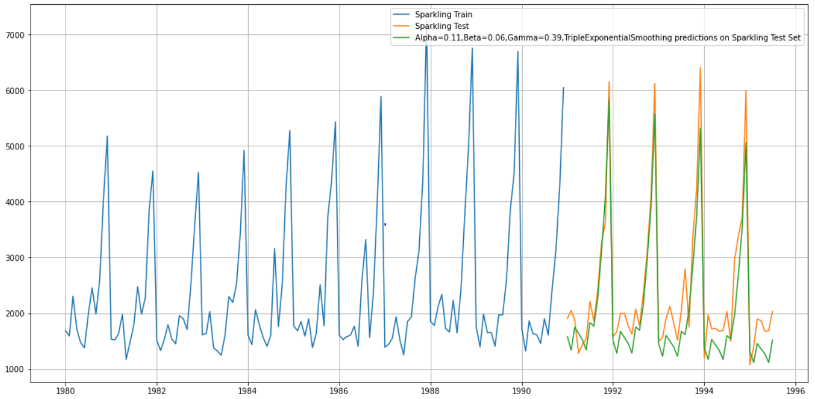

**Image 45: TES base model plot for Sparkling data**

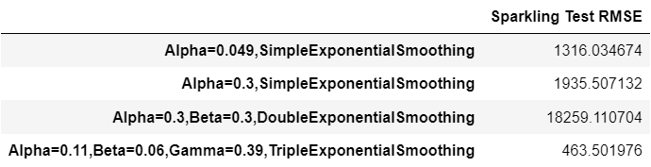

**Table 19: TES base model RMSE values for sparkling data**

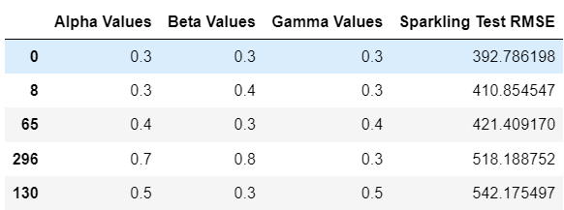

**Table 20: TES optimal parameter values for sparkling data**

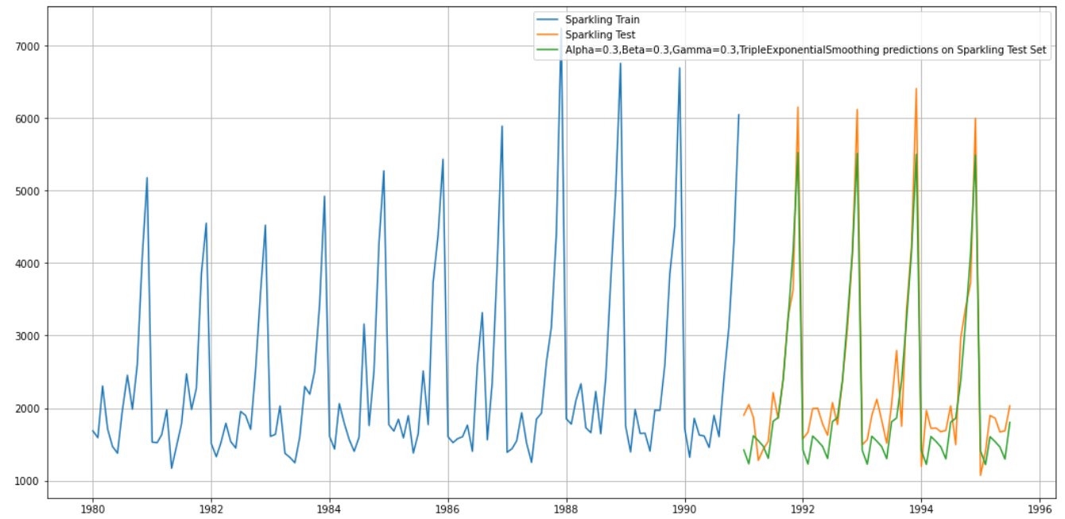

**Image 46: TES optimal model plot for Sparkling data**

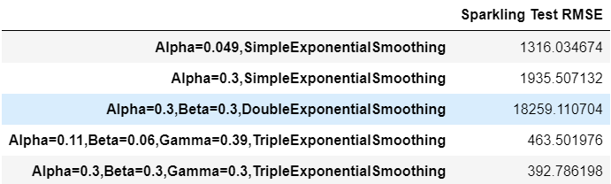

**Table 21: TES optimal RMSE values for sparkling data**

Inference- We see that the Triple Exponential Smoothing is picking up the seasonal component as well. Triple Exponential Smoothing has performed the best on the test as expected since the data had both trend and seasonality.

Estimated parameter for rose wine-

{'smoothing_level': 0.06571007449183297,'smoothing_trend': 0.051867105713176015,'smoothing_seasonal': 0.0015637515713898,'damping_trend': nan,'initial_level': 47.81887301367471,'initial_trend': -0.2961562797665537,'initial_seasons': array ([2.35763018, 2.67367218, 2.92146068, 2.55308191, 2.87099548,3.13124987, 3.44178442, 3.66118656, 3.47154364, 3.39670325,3.95879831, 5.46173463]),'use_boxcox': False,'lamda': None,'remove_bias': False}

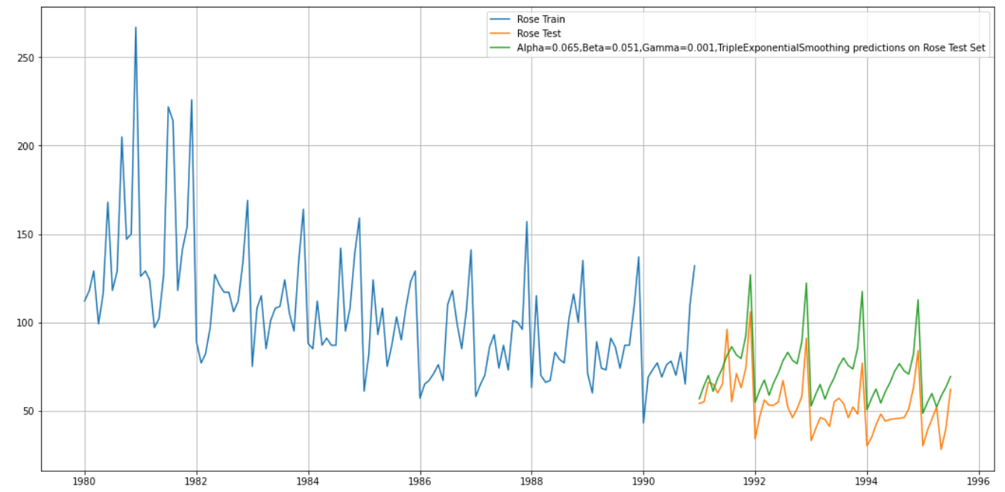

**Image 47: TES base model plot for Rose data**

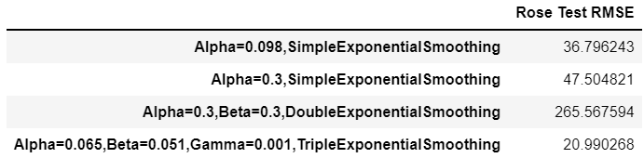

**Table 22: TES base RMSE values for rose data**

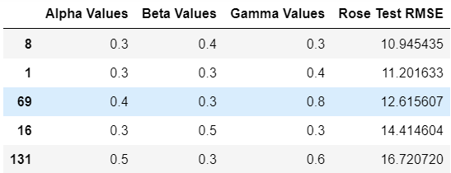

**Table 23: TES best parameter values for rose data**

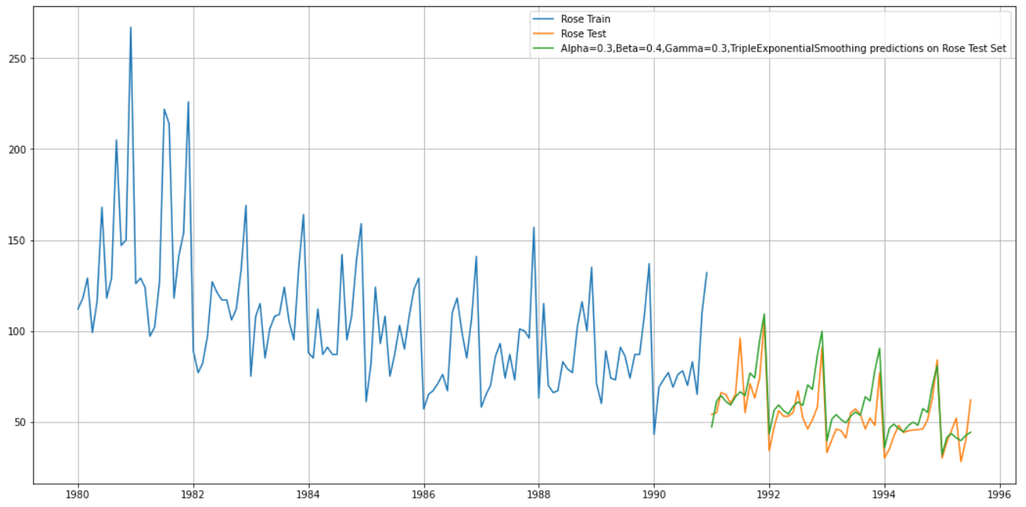

**Image 48: TES optimal model plot for Rose data**

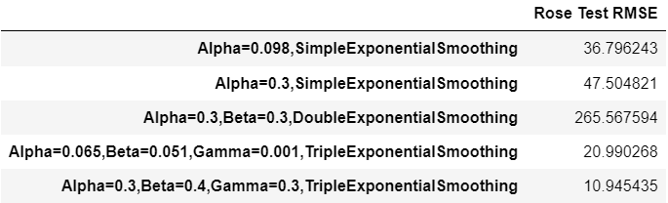

**Table 24: TES best RMSE values for rose data**

Inference- We see that the Triple Exponential Smoothing is picking up the seasonal component as well. Triple Exponential Smoothing has performed the best on the test as expected since the data had both trend and seasonality.

#### Linear Regression- For this particular linear regression, we are going to regress the 'Sparkling' and ‘Rose’ variables against the order of the occurrence. For this we need to modify our training data before fitting it into a linear regression. We see that we have successfully the generated the numerical time instance order for both the training and test set as shown below. Now we will add these values in the training and test set.

Sparkling Training Time instance

[1, 2, 3, 4, 5, 6, 7, 8, 9, 10, 11, 12, 13, 14, 15, 16, 17, 18, 19, 20, 21, 22, 23, 24, 25, 26, 27, 28, 29, 30, 31, 32, 33, 34, 35, 36, 37, 38, 39, 40, 41, 42, 43, 44, 45, 46, 47, 48, 49, 50, 51, 52, 53, 54, 55, 56, 57, 58, 59, 60, 61, 62, 63, 64, 65, 66, 67, 68, 69, 70, 71, 72, 73, 74, 75, 76, 77, 78, 79, 80, 81, 82, 83, 84, 85, 86, 87, 88, 89, 90, 91, 92, 93, 94, 95, 96, 97, 98, 99, 100, 101, 102, 103, 104, 105, 106, 107, 108, 109, 110, 111, 112, 113, 114, 115, 116, 117, 118, 119, 120, 121, 122, 123, 124, 125, 126, 127, 128, 129, 130, 131, 132]

Sparkling Test Time instance

[133, 134, 135, 136, 137, 138, 139, 140, 141, 142, 143, 144, 145, 146, 147, 148, 149, 150, 151, 152, 153, 154, 155, 156, 157, 158, 159, 160, 161, 162, 163, 164, 165, 166, 167, 168, 169, 170, 171, 172, 173, 174, 175, 176, 177, 178, 179, 180, 181, 182, 183, 184, 185, 186, 187]

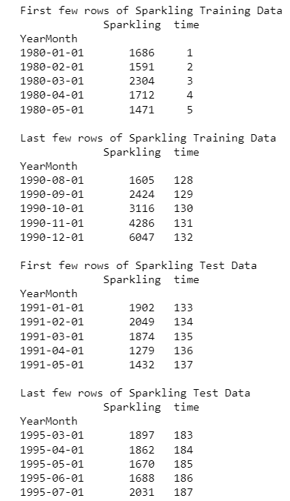

**Image 49: Regression model rows for Sparkling data**

Now that our training and test data has been modified, let us go ahead use Linear Regression to build the model on the training data and test the model on the test data.

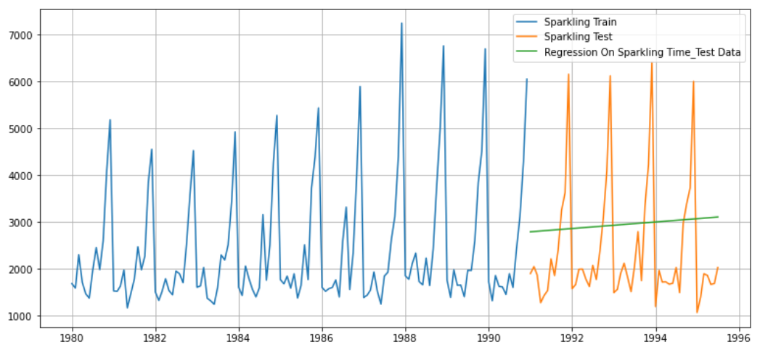

**Image 50: Regression model plot for Sparkling data**

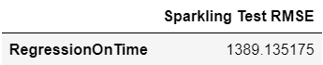

**Table 25: Regression model evaluation for sparkling data**

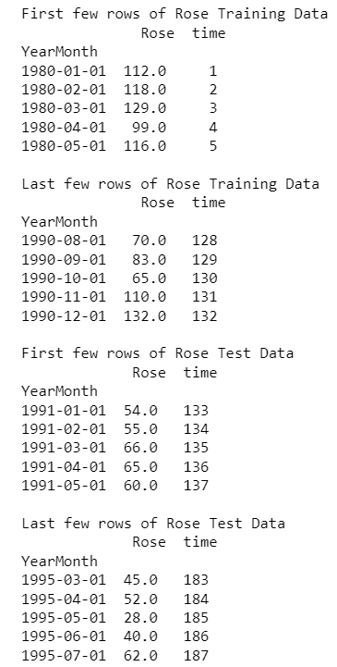

**Image 51: Regression model rows for Rose data**

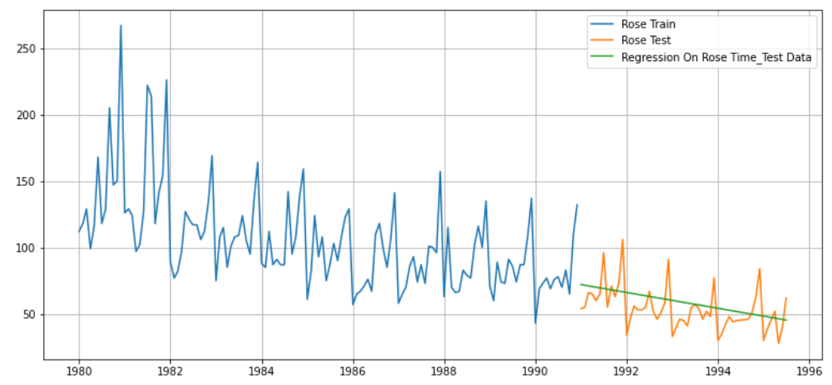

**Image 52: Regression model plot for Rose data**

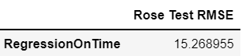

**Table 26: Regression model evaluation for rose data**

Inference- Error term is quite high for sparkling data and the corresponding plot has a constant trendline whereas for rose data, error term is low with a decreasing trendline.

Naive Approach- For this particular naive model, we say that the prediction for tomorrow is the same as today and the prediction for day after tomorrow is tomorrow and since the prediction of tomorrow is same as today, therefore the prediction for day after tomorrow is also today.

## 

**Image 53: Naive model plot for Rose data**

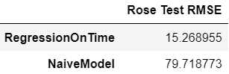

**Table 27: Naive model evaluation for rose data**

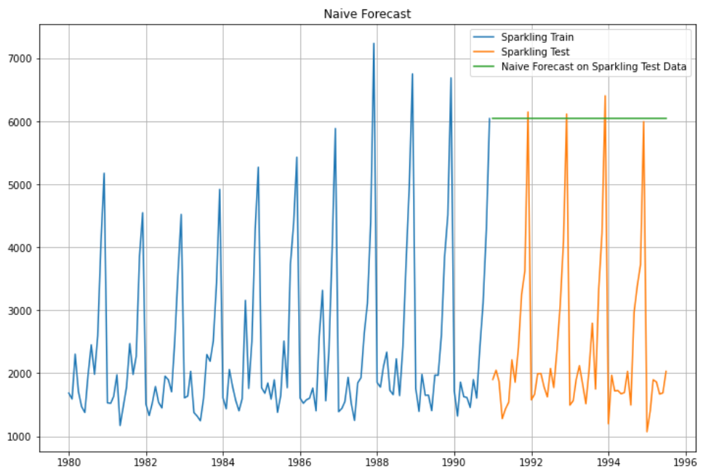

**Image 54: Naive model plot for Sparkling data**

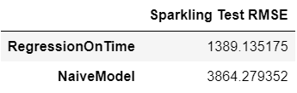

**Table 28: Naive model evaluation for sparkling data**

Inference**-** Sparkling and wine sales is predicted to be constant over the future by this model. Accuracy of the naïve model is not as good as the linear regression model as shown by huge difference in error values for both datasets.

Simple Average - For this particular simple average method, we will forecast by using the average of the training values.

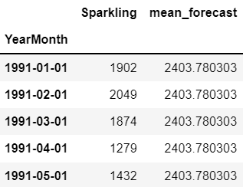

**Table 29: Average forecast for sparkling**

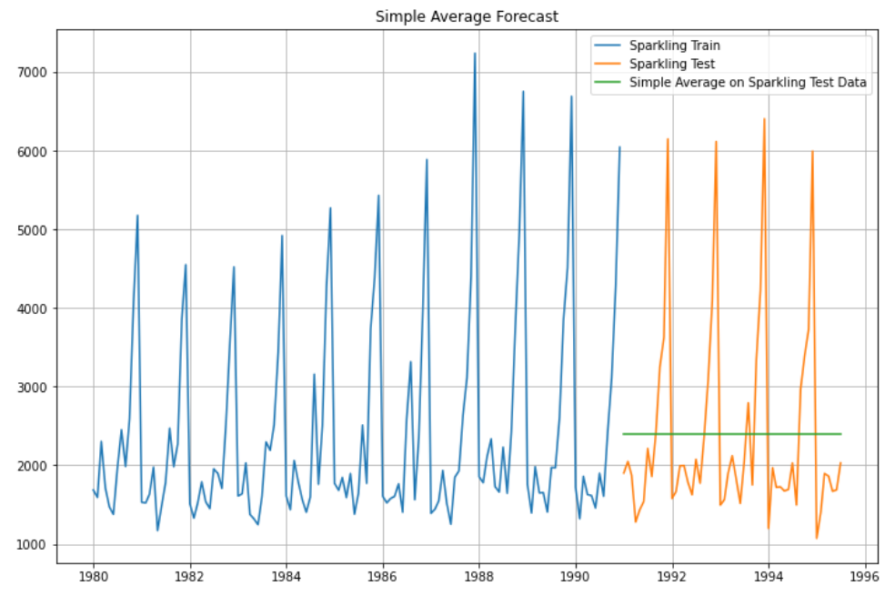

**Image 55: Simple Average model plot for sparkling data**

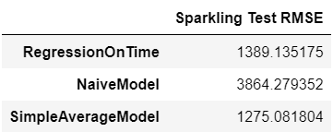

**Table 30: RMSE values for simple average sparkling data**

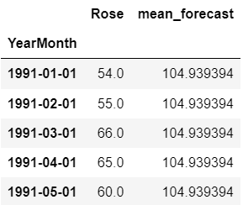

**Table 31: Rose simple average forecast**

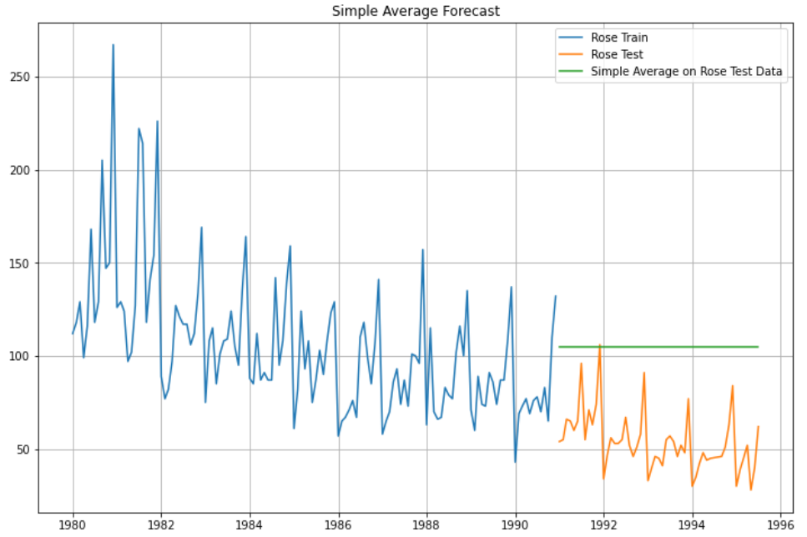

**Image 56: Simple Average model plot for rose data**

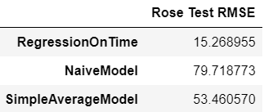

**Table 32: RMSE for simple average rose data**

Inference – Sparkling wine data performs better on simple average model than linear regression and naïve forecast due to error values decreasing to some extent. However, for rose data accuracy is an improvement from naïve model but linear regression still stands out. The trendline indicates a uniform sale of sparkling and rose wines over the coming years.

Moving average forecast - Moving Average Smoothing is a naive and effective technique in time series forecasting. Smoothing is a technique applied to time series to remove the fine-grained variation between time steps. Calculating a moving average involves creating a new series where the values are comprised of the average of raw observations in the original time series. A moving average requires that you specify a window size called the window width. This defines the number of raw observations used to calculate the moving average value.

The rolling () function on the Series Pandas object will automatically group observations into a window. We can specify the window size, and by default, a trailing window is created. Once the window is created, we can use the mean value, which forms our transformed dataset.

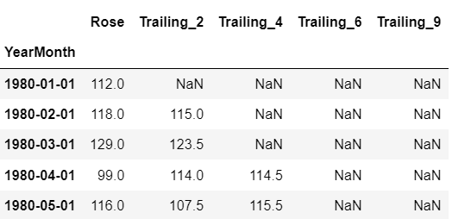

**Table 33: Trailing moving average rose data**

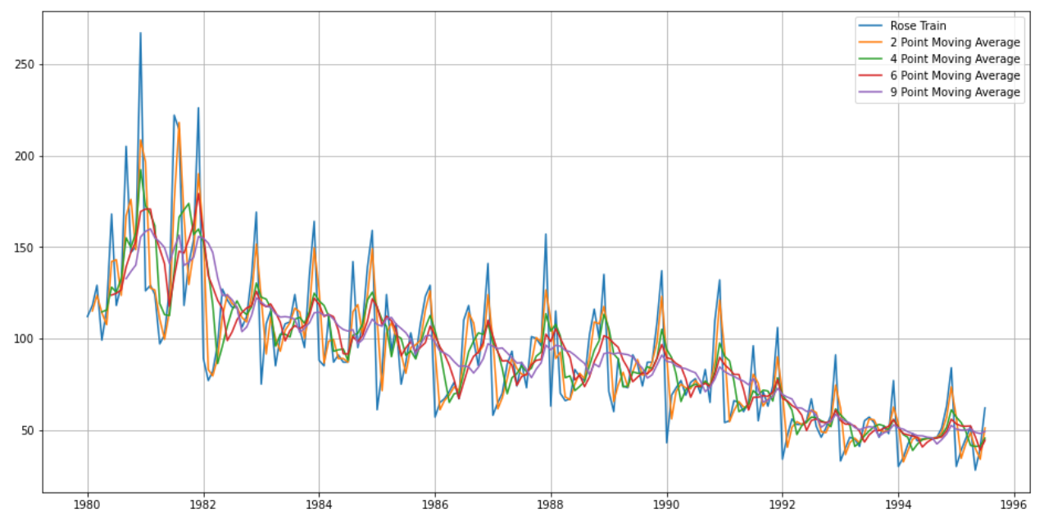

**Image 57: Moving Average model plot for entire rose data**

Let us split the data into train and test and plot this Time Series. The window of the moving average is need to be carefully selected as too big a window will result in not having any test set as the whole series might get averaged over.

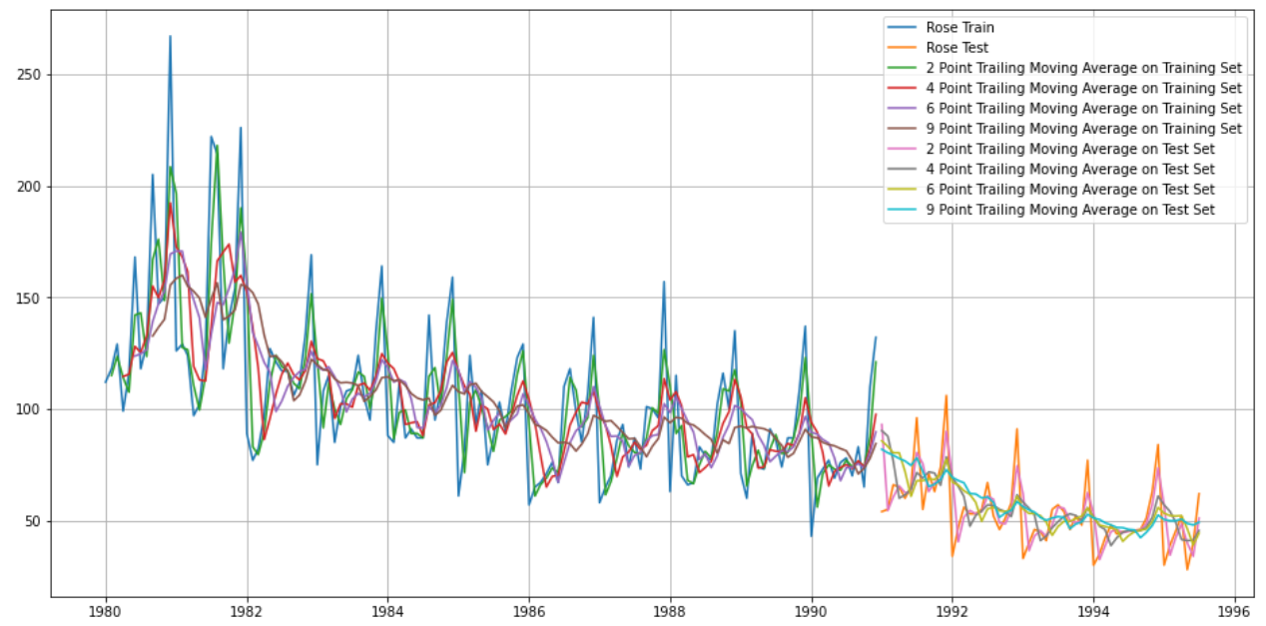

**Image 58: Moving Average model plot for rose train and test data**

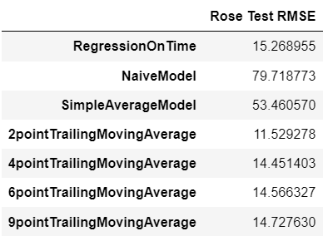

**Table 34: RMSE values for moving average rose data**

Inference - Moving average line is close to the original data line. 2 point moving average has the best accuracy out of all the models for rose wine data.

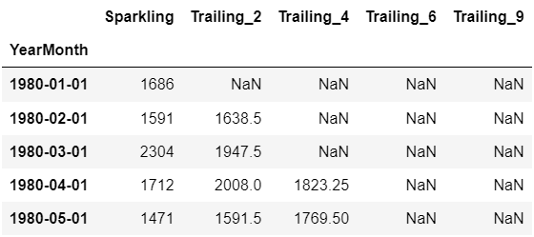

**Table 35: Sparkling data trailing moving average**

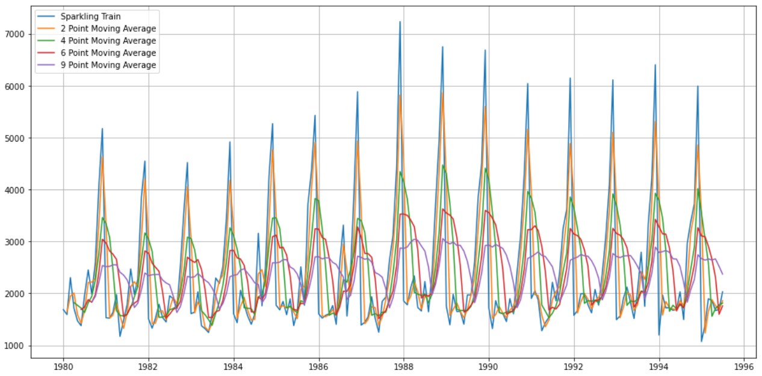

**Image 59: Moving Average model plot for whole sparkling data**

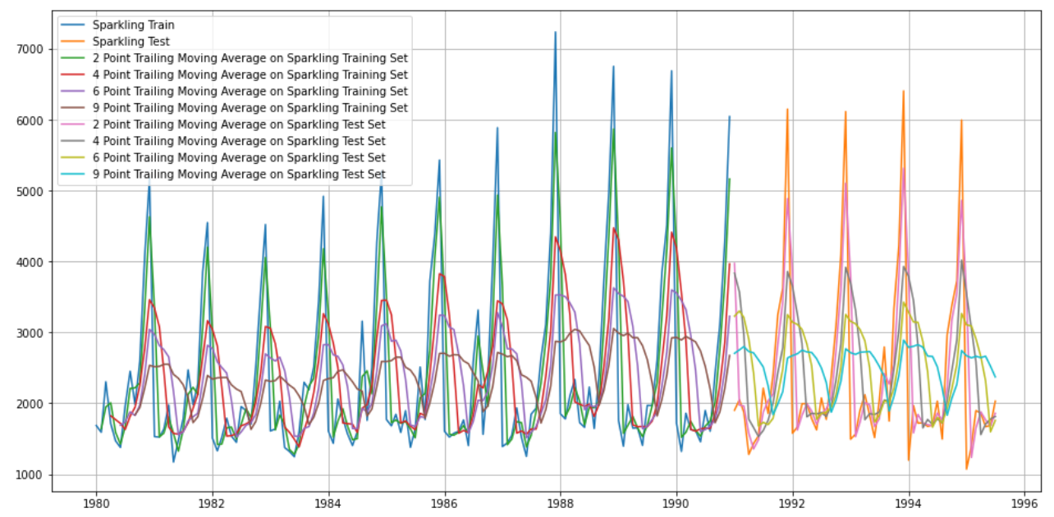

**Image 60: Moving Average model plot for sparkling train and test**

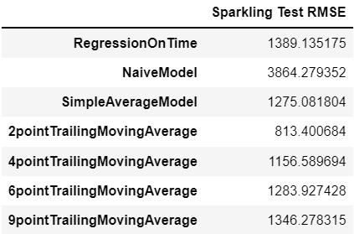

**Table 36: Sparkling data moving average RMSE values**

Inference - Moving average line is close to the original data line. 2 point moving average has the best performance out of all the models for sparkling wine data.

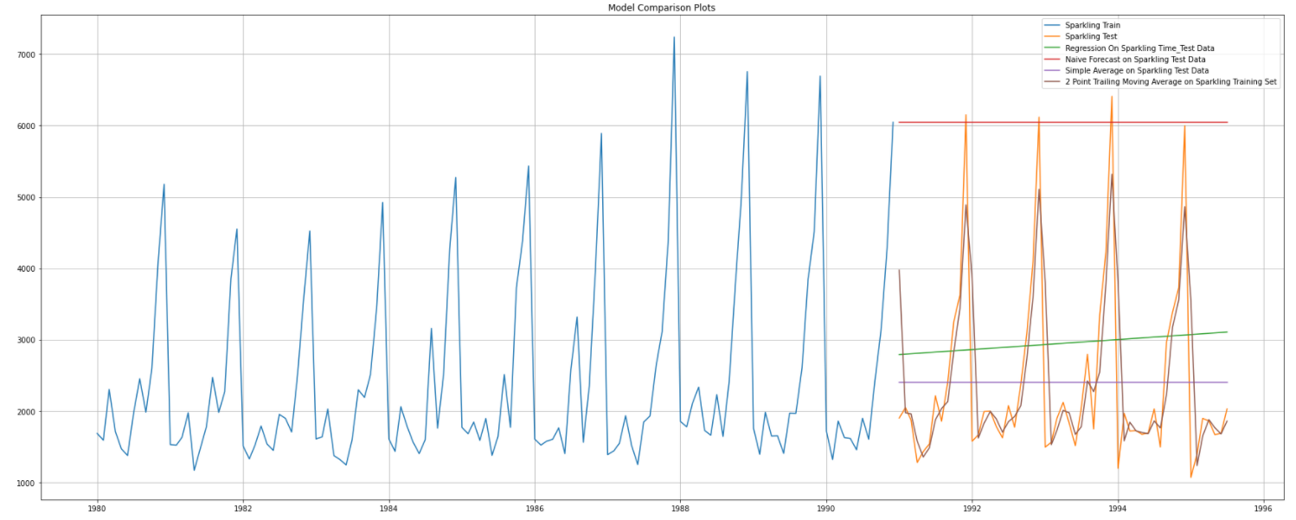

**Image 61: Model comparison plot for sparkling dataset**

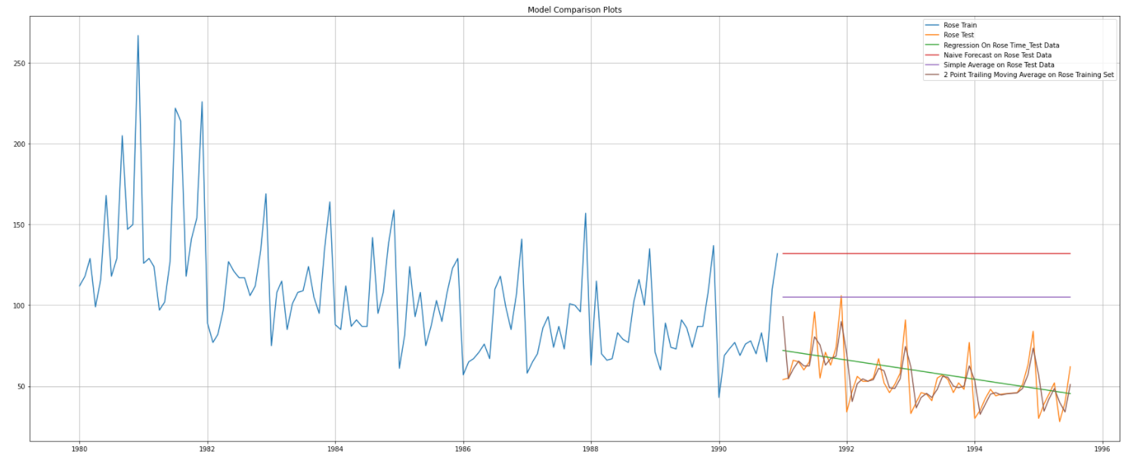

**Image 62: Model comparison plot for rose dataset**

**Q 5. Check for the stationarity of the data on which the model is being built on using appropriate statistical tests and also mention the hypothesis for the statistical test. If the data is found to be non-stationary, take appropriate steps to make it stationary. Check the new data for stationarity and comment.**

The Augmented Dickey-Fuller test is a unit root test which determines whether there is a unit root and subsequently whether the series is non-stationary.

The hypothesis in a simple form for the ADF test is:

* H0: The Time Series has a unit root and is thus non-stationary.
* H1: The Time Series does not have a unit root and is thus stationary.

We would want the series to be stationary for building ARIMA models and thus we would want the p-value of this test to be less than the α value.

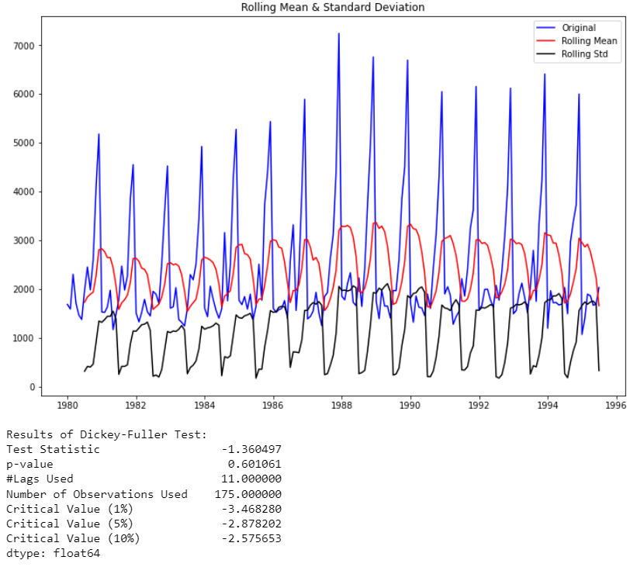

**Image 63: Stationary plot for sparkling dataset**

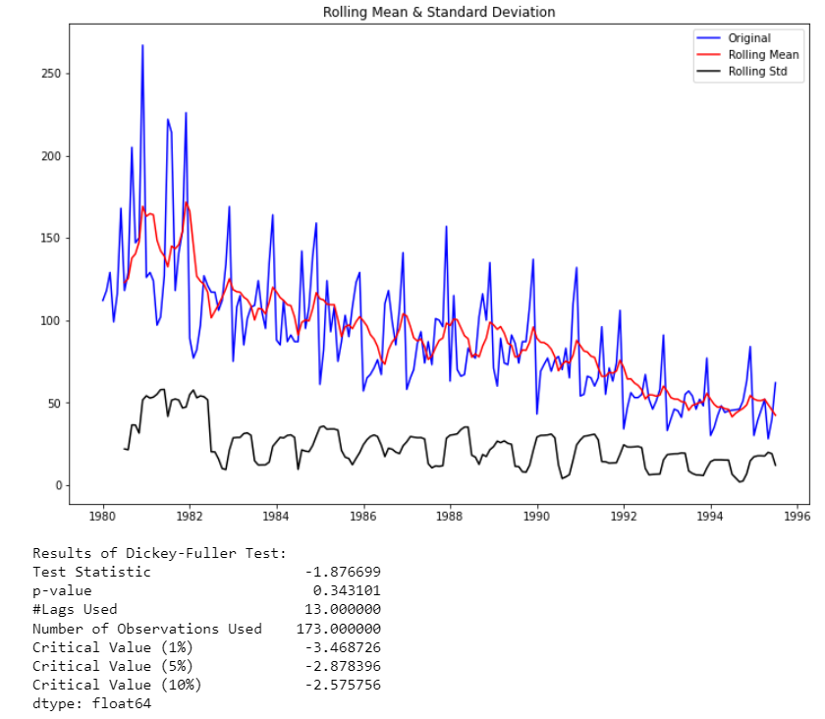

**Image 64: Stationarity plot for rose dataset**

We see that at 5% significant level the Time Series is non-stationary for both the datasets. Let us take one level of differencing to see whether the series becomes stationary.

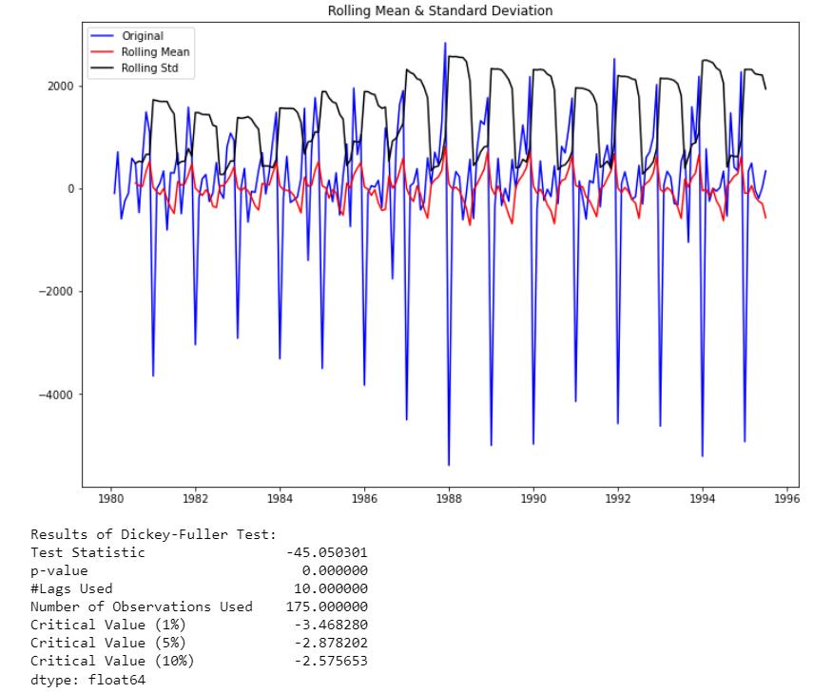

**Image 65: Differentiated stationarity plot for sparkling dataset**

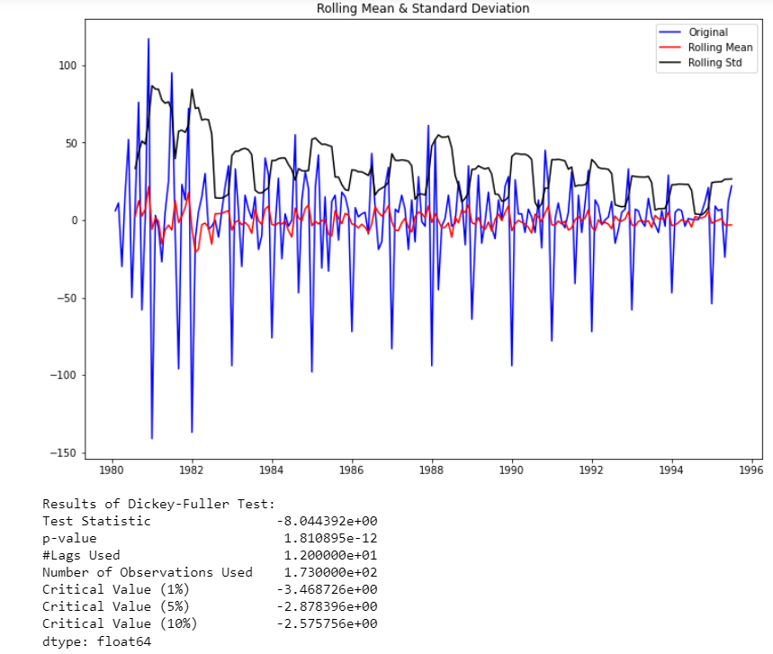

**Image 66: Differentiated stationarity plot for rose dataset**

We see that after taking a difference of order 1 the series have become stationary at α = 0.05.

**Q 6. Build an automated version of the ARIMA/SARIMA model in which the parameters are selected using the lowest Akaike Information Criteria (AIC) on the training data and evaluate this model on the test data using RMSE.**

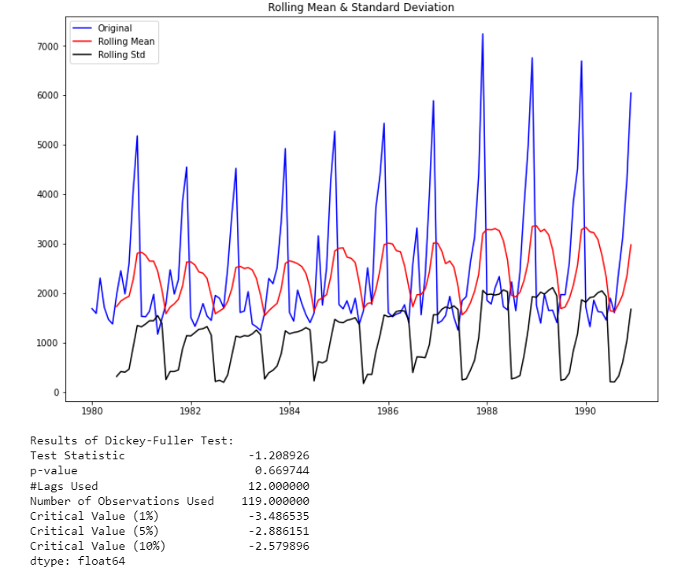

**Image 67: Stationarity plot for sparkling train dataset**

We see that the series is not stationary at α = 0.05.

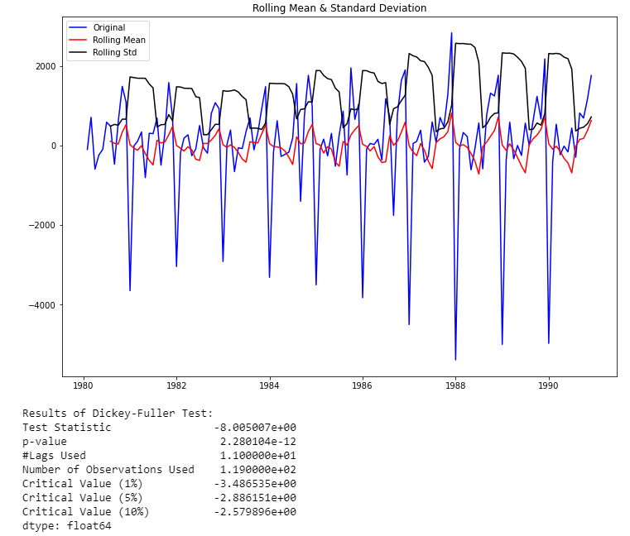

**Image 68: Differentiated stationarity plot for sparkling train dataset**

We see that after taking a difference of order 1 the series have become stationary at α = 0.05.

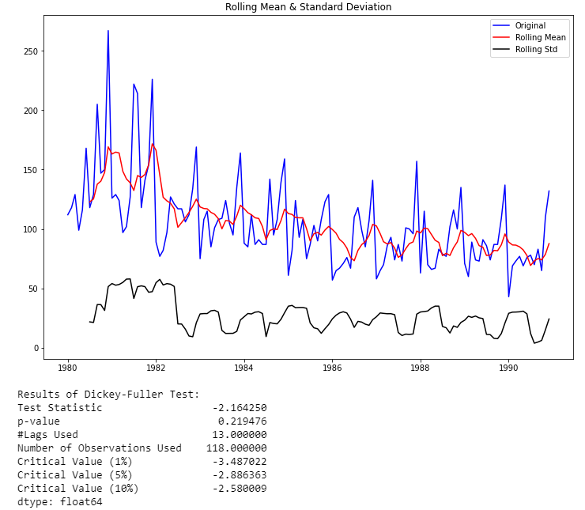

**Image 69: Stationarity plot for rose train dataset**

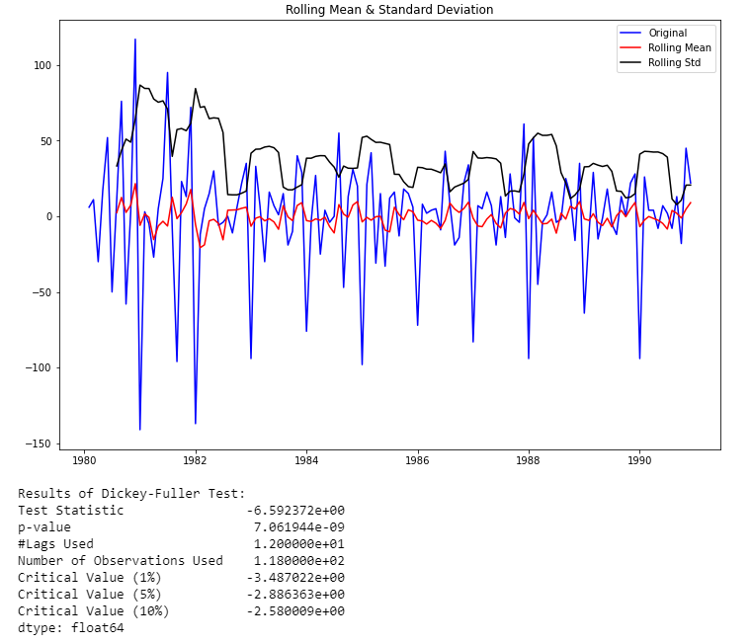

**Image 70: Differentiated stationarity plot for rose train dataset**

##### If the series is non-stationary, stationarize the Time Series by taking a difference of the Time Series. Then we can use this particular differenced series to train the ARIMA models. We do not need to worry about stationarity for the Test Data because we are not building any models on the Test Data, we are evaluating our models over there.

#### Auto-regressive (AR) and moving average (MA) models are popular models that are frequently used for forecasting. AR and MA models are combined to create models such as auto-regressive moving average (ARMA) and auto-regressive integrated moving average (ARIMA) models. ARMA models are basically regression models; auto-regression means regression of a variable on itself measured at different time periods. **A plot of auto-correlation of different lags is called** Autocorrelation Function (ACF). **A plot of partial auto-correlation for different values of lags is called** Partial Autocorrelation Function (PACF).

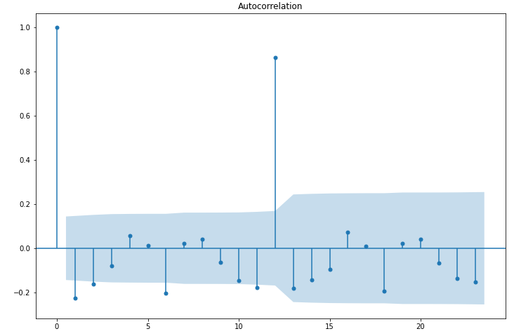

**Image 71: Differenced ACF plot for sparkling dataset**

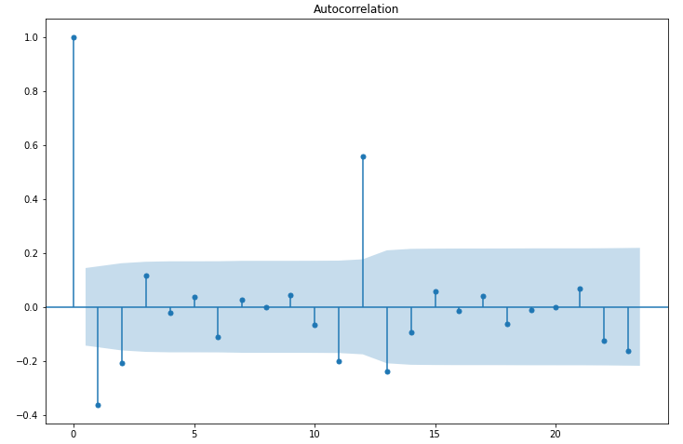

**Image 72: Differenced ACF plot for rose dataset**

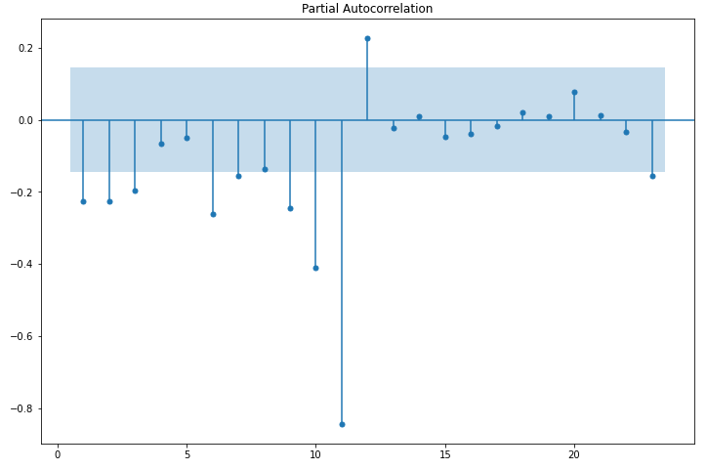

**Image 73: Differenced PACF plot for sparkling dataset**

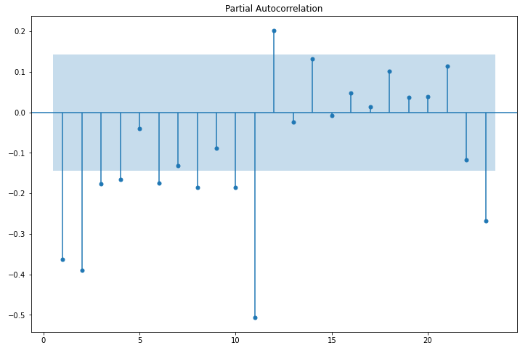

**Image 74: Differenced PACF plot for rose dataset**

From the above plots, we can say that there seems to be a seasonality in the data.

##### The data has some seasonality so ideally, we should build a SARIMA model. But for demonstration purposes we are building an ARIMA model both by looking at the minimum AIC criterion and by looking at the ACF and the PACF plots.

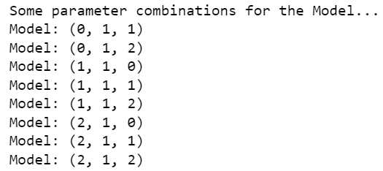

**Image 75: Combination of order and differences for sparkling ARIMA**

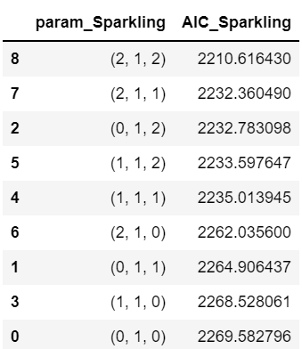

**Table 37: Minimum AIC values for sparkling wine**

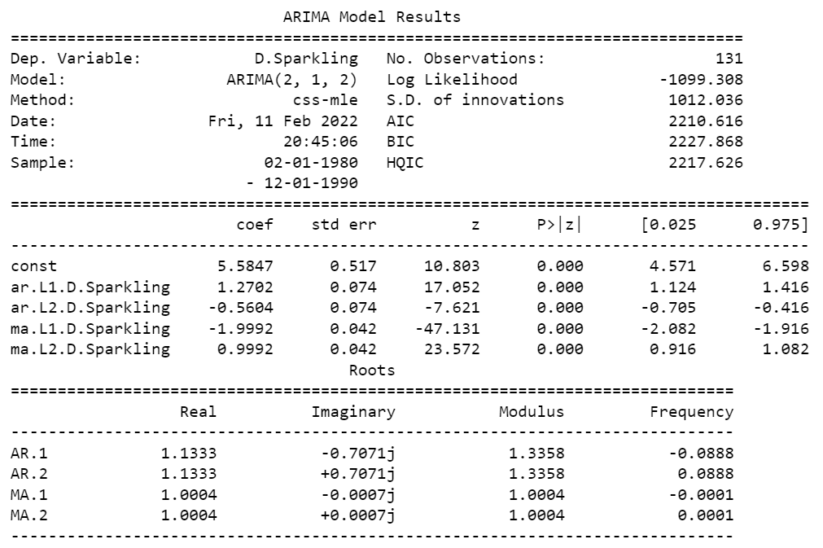

**Image 76: ARIMA model summary for sparkling data**

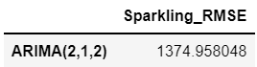

**Table 38: Optimal RMSE for sparkling ARIMA**

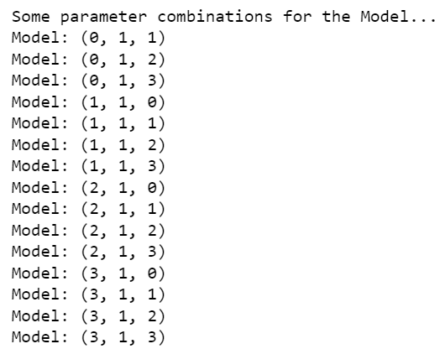

**Image 77: Combination of order and differences of rose wine**

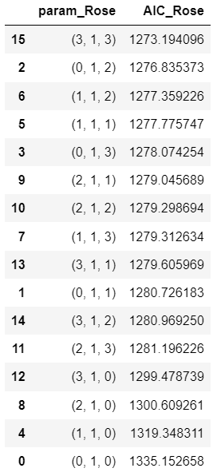

**Table 39: Optimal AIC for rose ARIMA**

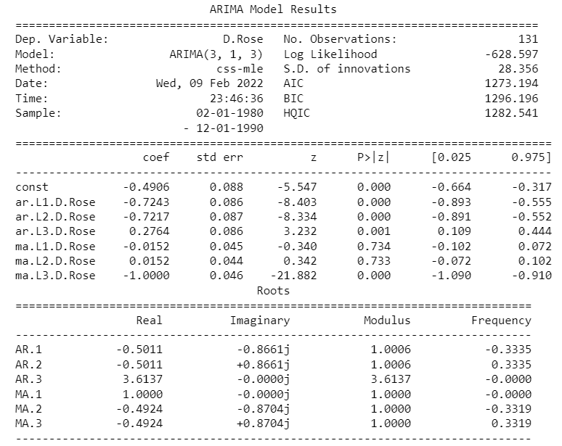

**Image 78: ARIMA model summary for rose data**

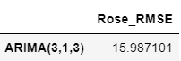

**Table 40: Optimal RMSE for rose ARIMA**

Let us look at the ACF plot once more to understand the seasonal parameter for the SARIMA model. We see that there can be a seasonality of 6 as well as 12. We will run our auto SARIMA models by setting seasonality both as 6 and 12.

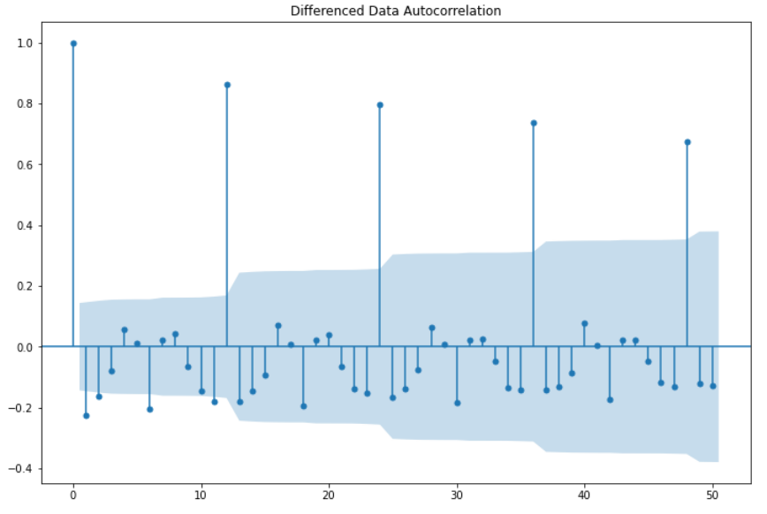

**Image 79: ACF differenced plot for sparkling sample**

### Setting the seasonality as 6 for the first iteration of the auto SARIMA model,

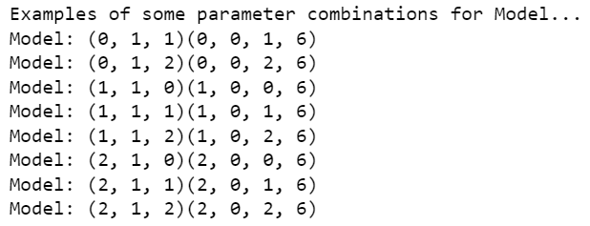

**Image 80: Parameter combinations for SARIMA**

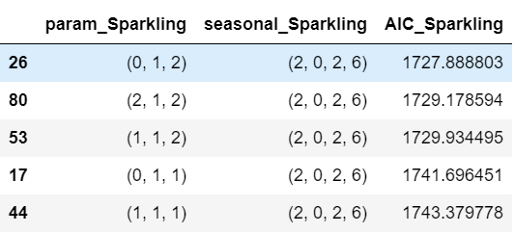

**Table 41: Optimal AIC for sparkling SARIMA**

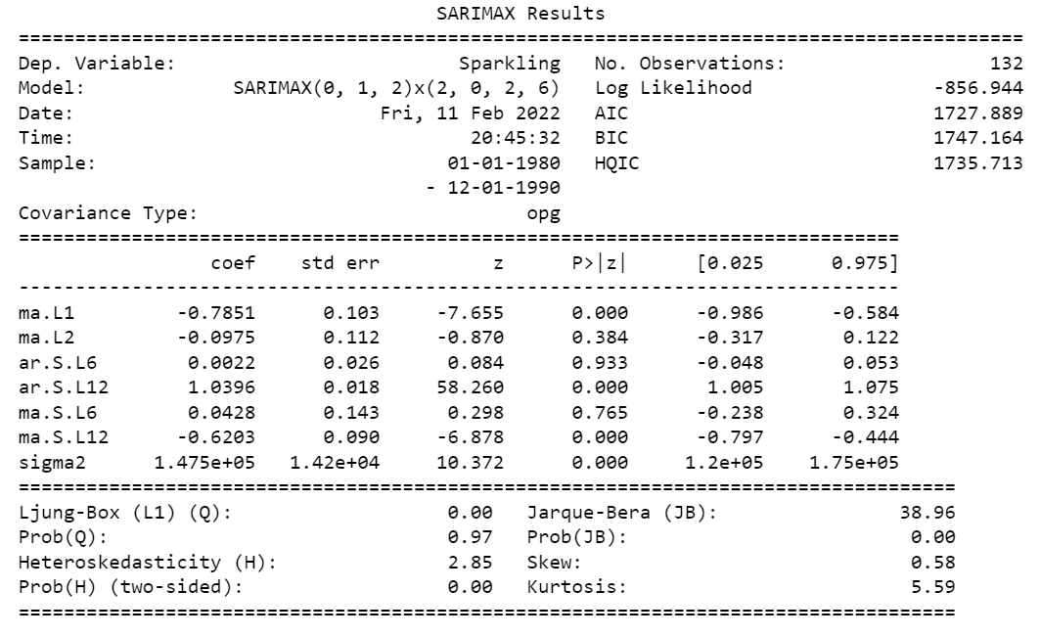

**Image 81: Model summary for sparkling SARIMA**

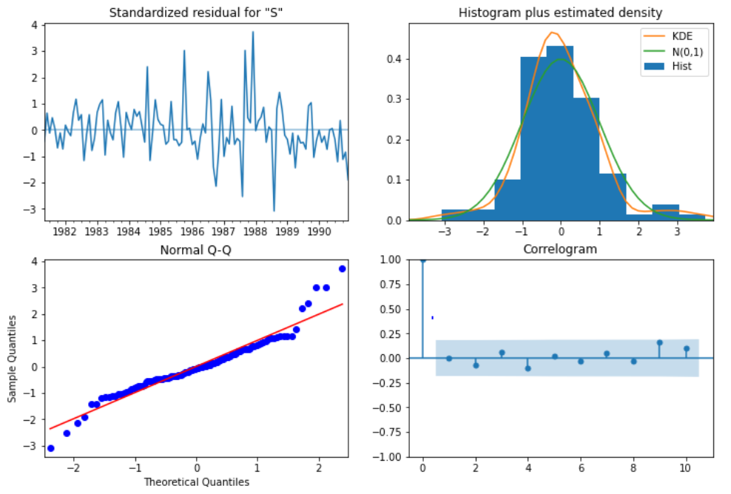

**Image 82: Model diagnostic plot for sparkling SARIMA**

From the model diagnostics plot, we can see that all the individual diagnostics plots almost follow the theoretical numbers and thus we cannot develop any pattern from these plots.

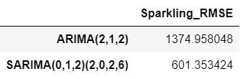

**Table 42: Model Evaluation for sparkling SARIMA**

We see that we have huge gain the RMSE value by including the seasonal parameters as well.

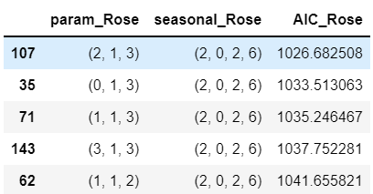

**Table 43: Optimal parameters for rose SARIMA**

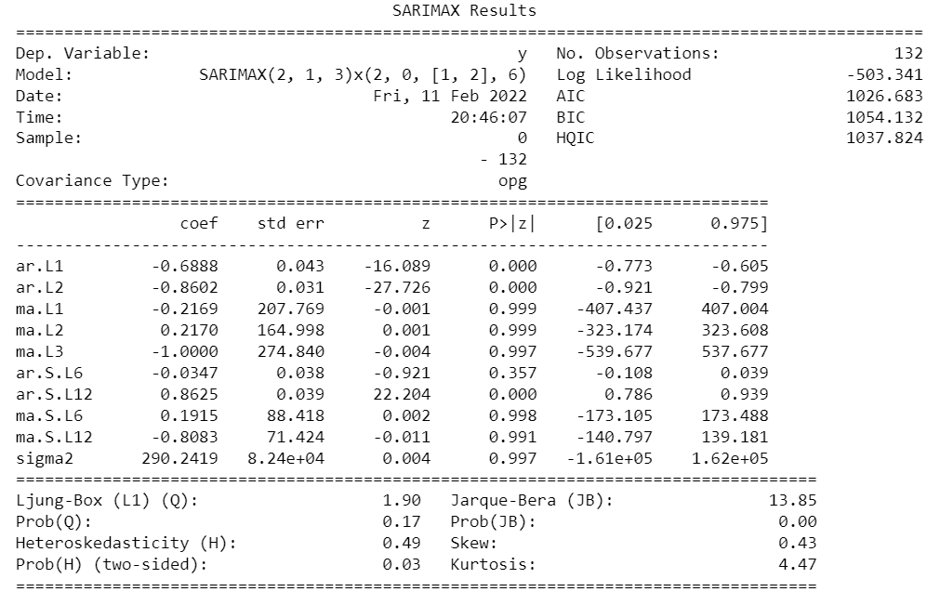

**Image 83: Model summary for rose SARIMA**

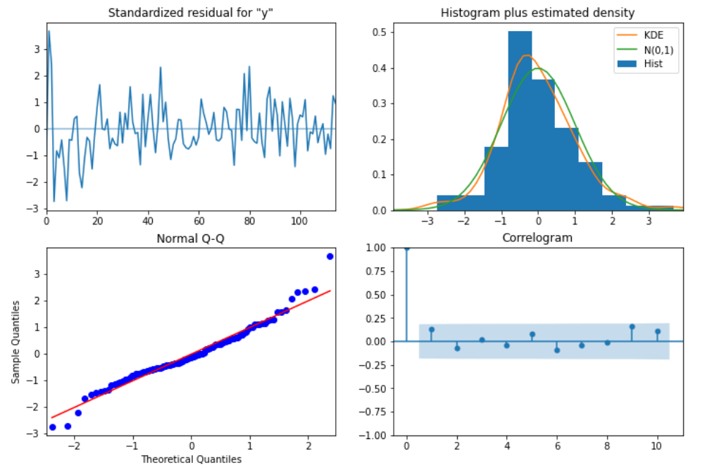

**Image 84: Model diagnostic plot for rose SARIMA**

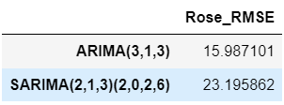

**Table 44: Optimal RMSE for rose SARIMA**

### Setting the seasonality as 12 for the second iteration of the auto SARIMA model.

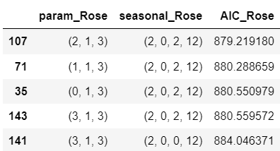

**Table 45: Optimal parameters for seasonality 12**

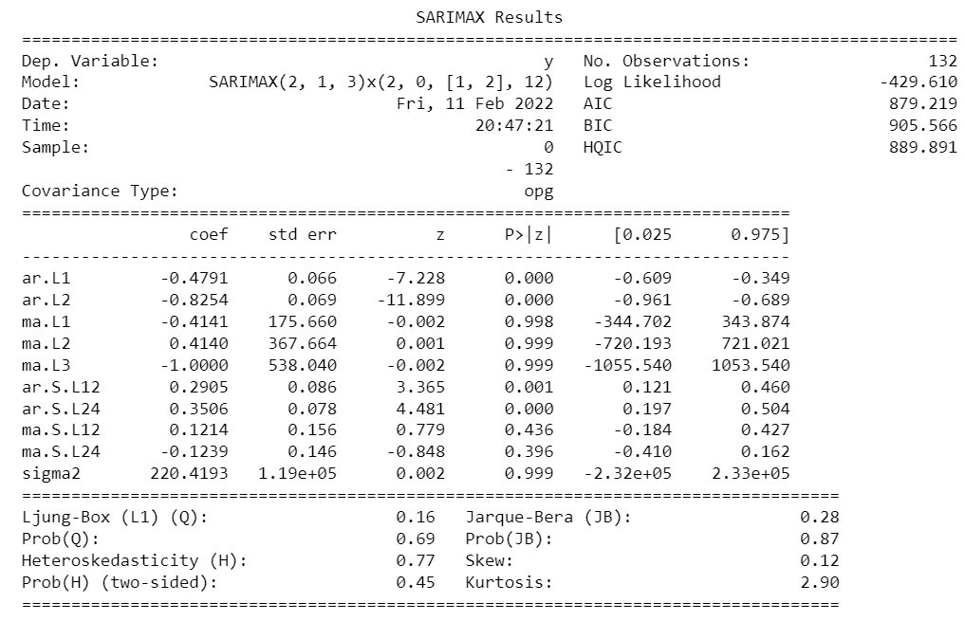

**Image 85: Model summary for seasonality 12**

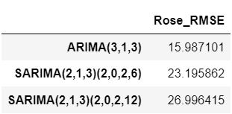

**Table 46: Optimal RMSE for seasonality 12**

We see that the RMSE value have not reduced further when the seasonality parameter was changed to 12.

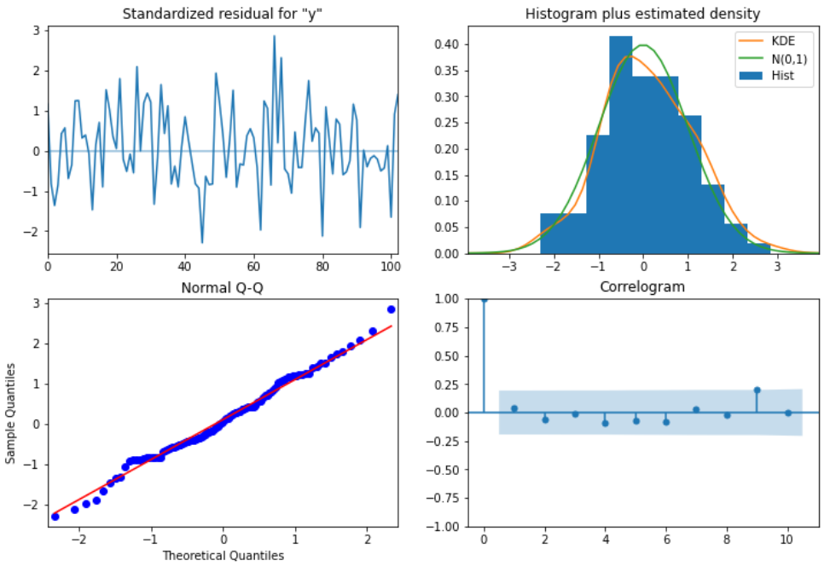

**Image 86: Model diagnostic plot for seasonality 12**

Similar to the last iteration of the model where the seasonality parameter was taken as 6, here also we see that the model diagnostics plot does not indicate any remaining information that we can get.

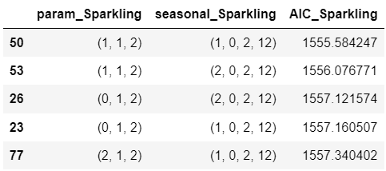

**Table 47: Optimal parameters for sparkling at seasonality 12**

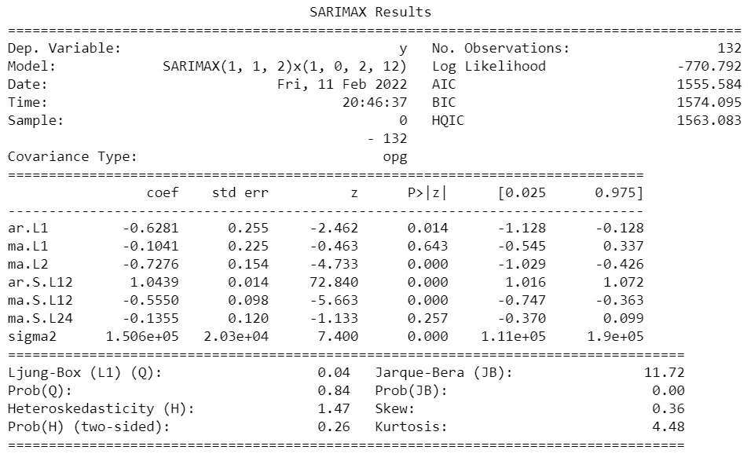

**Image 87: Model summary plot for sparkling at seasonality 12**

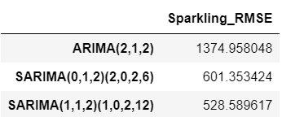

**Table 48: Optimal RMSE for sparkling at seasonality 12**

We see that the RMSE value have reduced further when the seasonality parameter was changed to 12.

**Q 7. Build ARIMA/SARIMA models based on the cut-off points of ACF and PACF on the training data and evaluate this model on the test data using RMSE.**

Let us look at the ACF and the PACF plots once more for both the datasets.

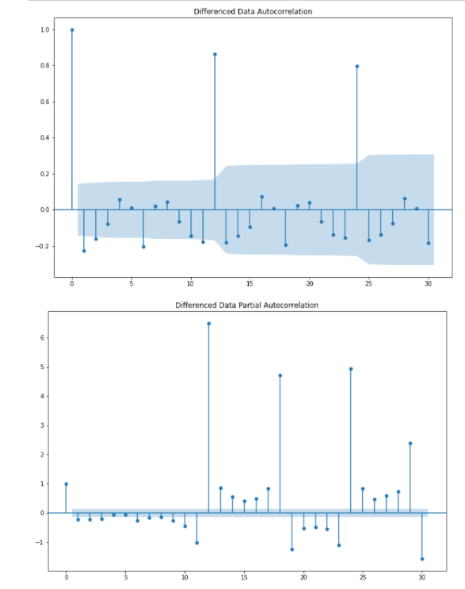

**Image 88: ACF and PACF plots with lag for sparkling**

Here, we have taken alpha=0.05.

* The Auto-Regressive parameter in an ARIMA model is 'p' which comes from the significant lag before which the PACF plot cuts-off to 0.
* The Moving-Average parameter in an ARIMA model is 'q' which comes from the significant lag before the ACF plot cuts-off to 2.

By looking at the above plots, we can say that both the PACF and ACF plot cuts-off at lag 0 and lag 2 respectively.

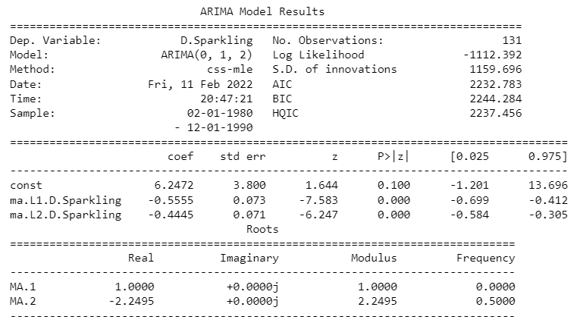

**Image 89: Model summary with lag for sparkling**

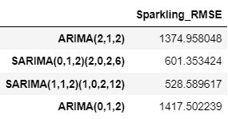

**Table 49: Optimal RMSE for ARIMA sparkling from plots**

We get a comparatively simpler model by looking at the ACF and the PACF plots. When we see that the AR(p) model are of order 0, we have to convert the input variable into a 'float64' type variable else Python might throw an error.

We see that there is difference in the RMSE values from the previous iteration of the models, but remember that the last model is a much simpler model.

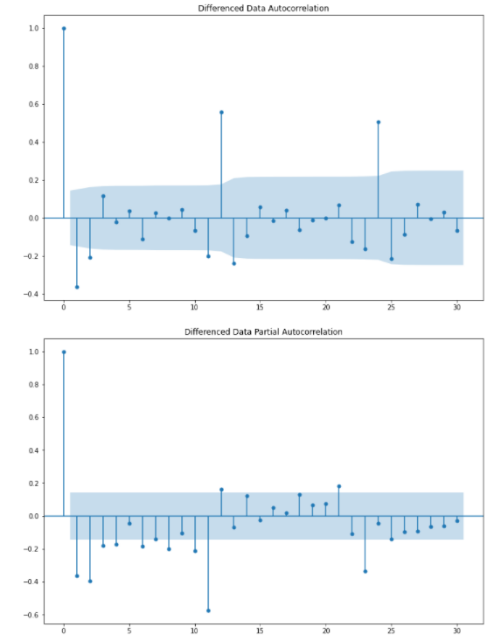

**Image 90: ACF and PACF plot with lag for rose**

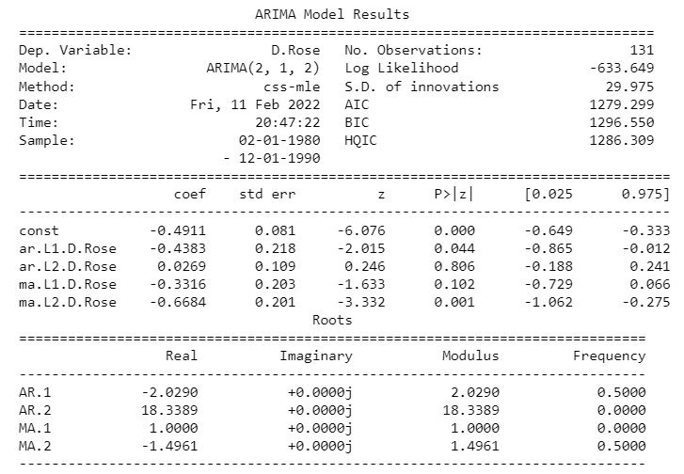

**Image 91: Model summary with lag for rose**

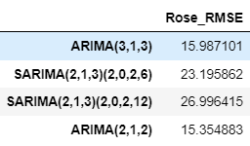

**Table 50: Optimal RMSE for ARIMA rose from plots**

We see that our ACF plot at the seasonal interval (12) does not taper off. So, we go ahead and take a seasonal differencing of the original series. Before that let us look at the original series.

We have already seen that there is a trend and a seasonality in the sparkling and rose time series plots. So, now we take a seasonal differencing and check the series.

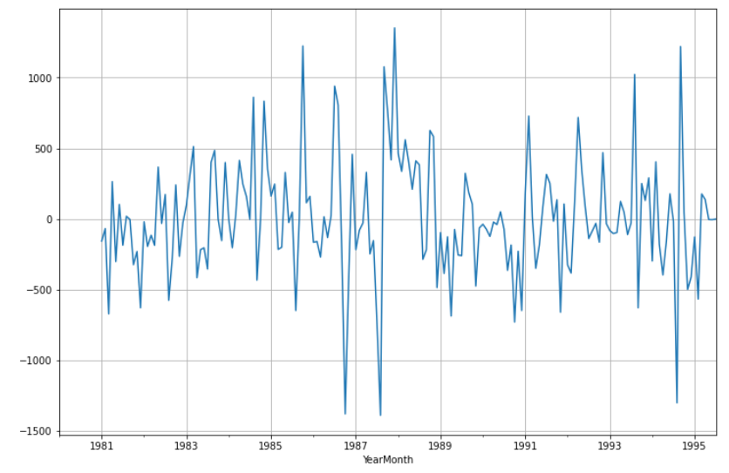

**Image 92: Seasonal difference plot of sparkling**

We see that there might be a slight trend which can be noticed in the data. So, we take a differencing of first order on the seasonally differenced series.

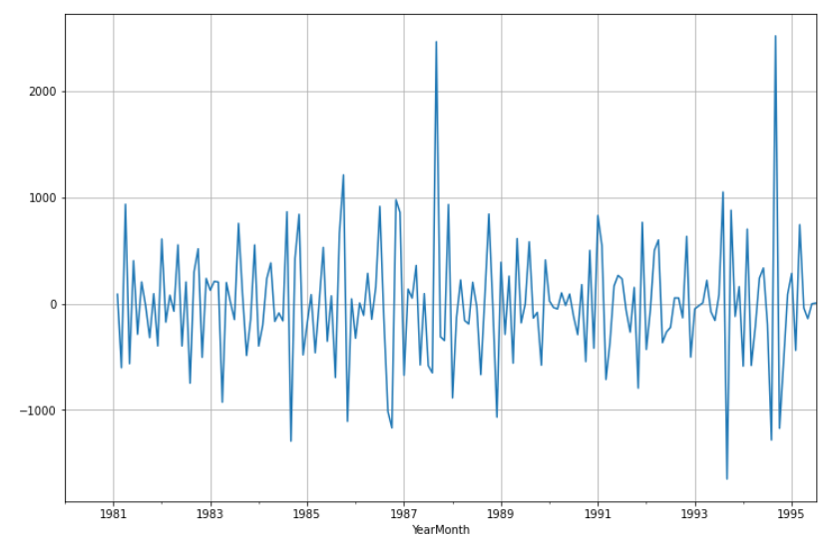

**Image 93: Seasonal difference plot of order 1 for sparkling**

Now we see that there is almost no trend present in the data. Seasonality is only present in the data.

Let us go ahead and check the stationarity of the above series before fitting the SARIMA model.

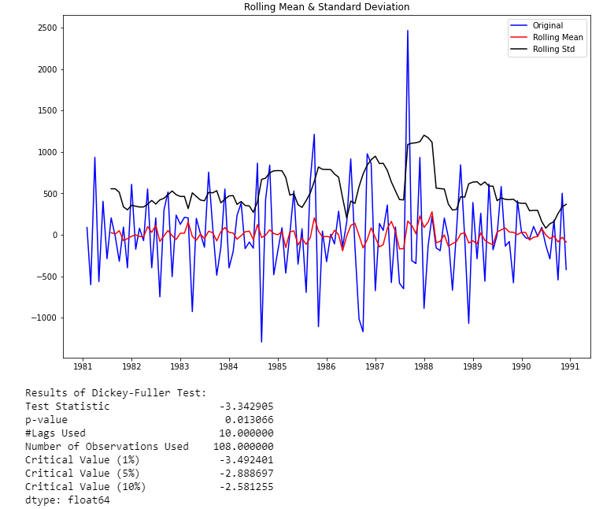

**Image 94: Stationarity of modified sparkling time series**

Checking the ACF and the PACF plots for the new modified Time Series.

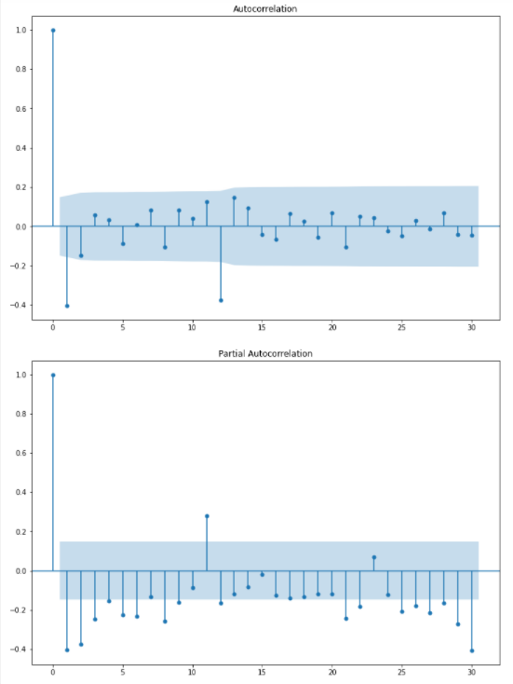

**Image 95: ACF and PACF plots of modified sparkling time series**

Here, we have taken alpha=0.05.

We are going to take the seasonal period as 12. We will keep the p (0) and q (2) parameters same as the ARIMA model.

* The Auto-Regressive parameter in a SARIMA model is 'P' which comes from the significant lag after which the PACF plot cuts-off to 2.
* The Moving-Average parameter in a SARIMA model is 'q' which comes from the significant lag after which the ACF plot cuts-off to 2. Remember to check the ACF and the PACF plots only at multiples of 12 (since 12 is the seasonal period).

By looking at the plots we see that the ACF and the PACF do not directly cut-off to 0.

This is a common problem while building models by looking at the ACF and the PACF plots. But we are able to explain the model.

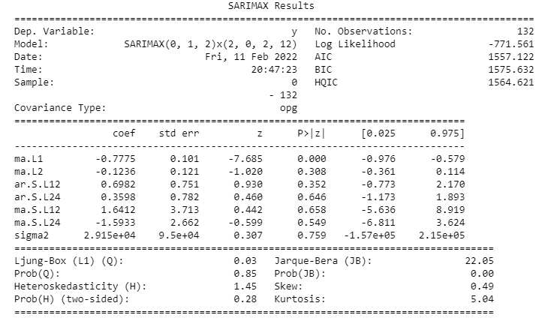

**Image 96: Model summary of modified sparkling time series**

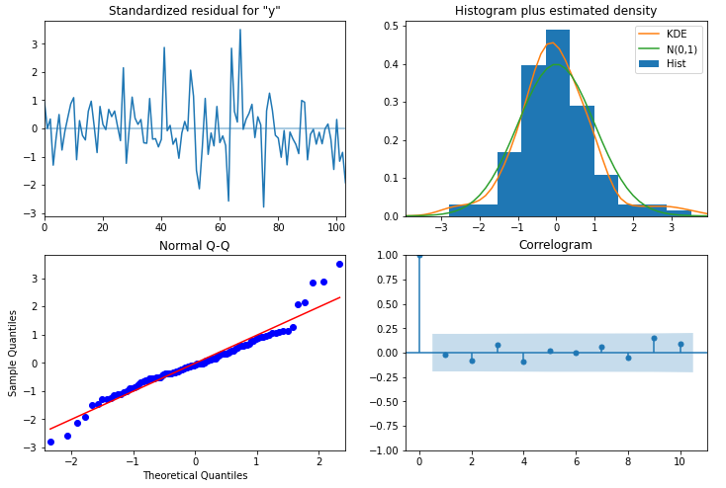

**Image 97: Model diagnostic plot of modified sparkling time series**

The model diagnostics plot looks okay.

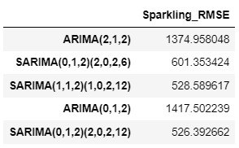

**Table 51: Optimal RMSE for SARIMA sparkling from plots**

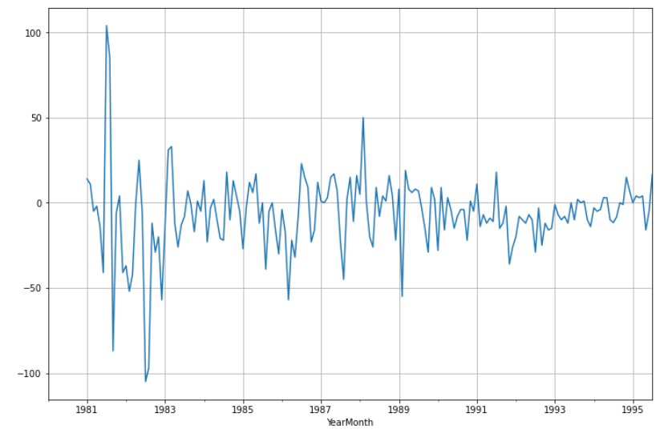

**Image 98: Seasonal difference plot for rose wine**

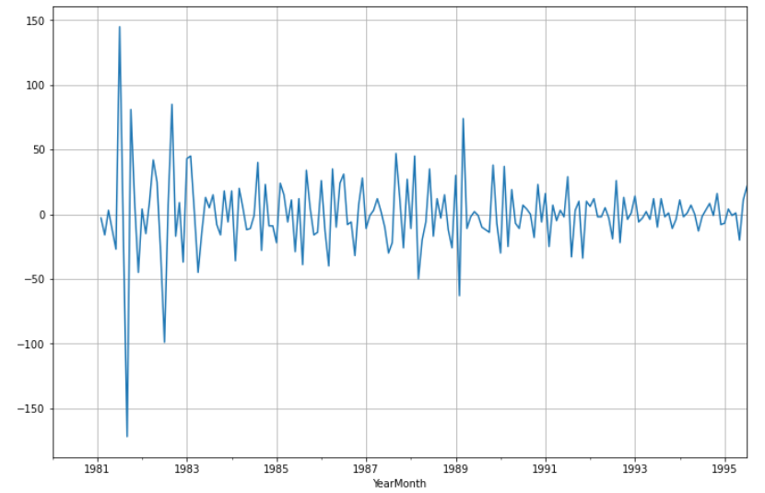

**Image 99: Seasonal difference plot of order 1 for rose wine**

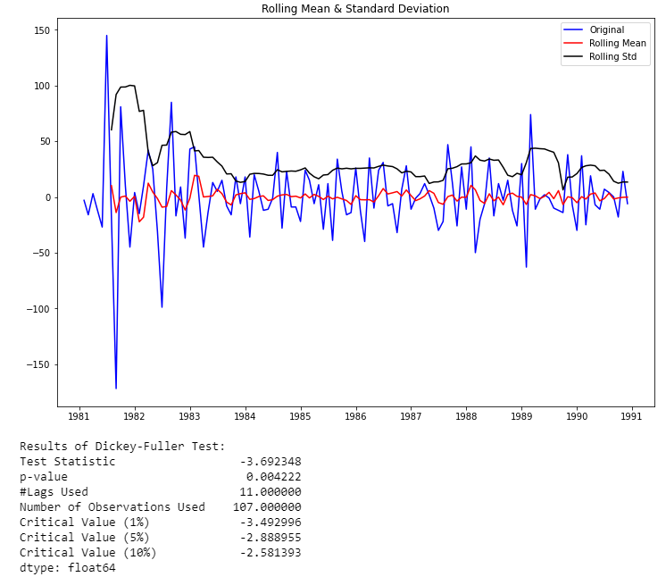

**Image 100: Stationarity plot of seasonal differencing rose wine**

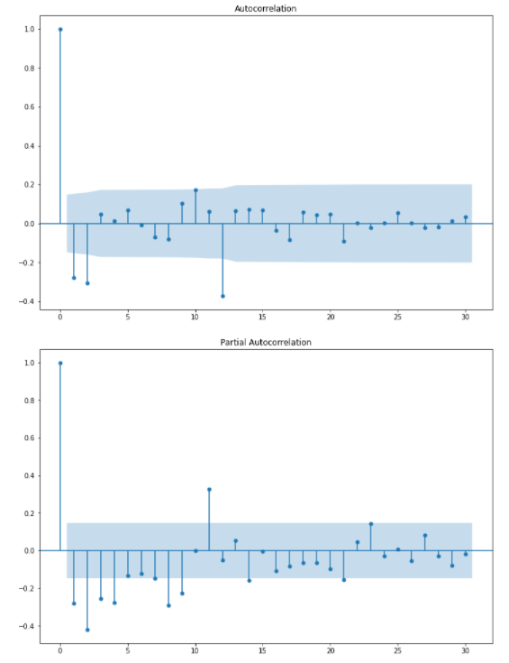

**Image 101: ACF and PACF plots of modified rose series**

Here, we have taken alpha=0.05.

We are going to take the seasonal period as 12. We will keep the p (2) and q (2) parameters same as the ARIMA model.

* The Auto-Regressive parameter in a SARIMA model is 'P' which comes from the significant lag after which the PACF plot cuts-off to 2.
* The Moving-Average parameter in a SARIMA model is 'q' which comes from the significant lag after which the ACF plot cuts-off to 2. Remember to check the ACF and the PACF plots only at multiples of 12 (since 12 is the seasonal period).

By looking at the plots we see that the ACF and the PACF do not directly cut-off to 0.

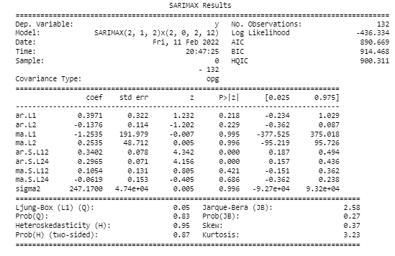

**Image 102: Model summary of modified rose series**

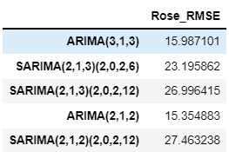

**Table 52: Optimal RMSE for SARIMA rose from plots**

This is where our model building exercise ends.

**Q 8. Build a table with all the models built along with their corresponding parameters and the respective RMSE values on the test data.**

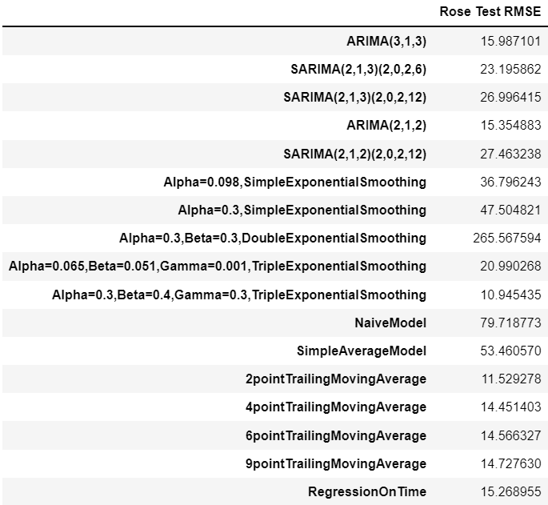

**Table 53: All models of rose wine**

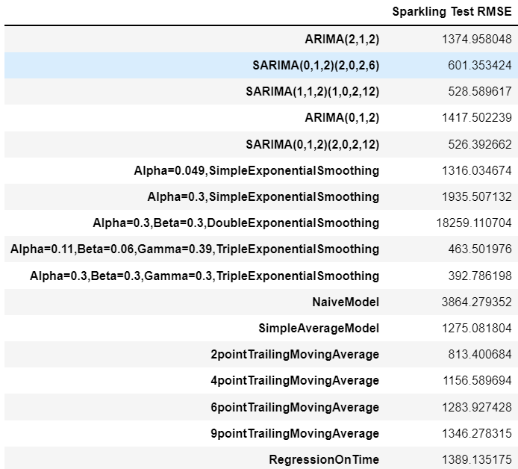

**Table 54: All models of Sparkling wine**

### We see that the best model is the Triple Exponential Smoothing with multiplicative seasonality with the parameters α = 0.3, β = 0.3 and **γ** = 0.3 for sparkling dataset and with the parameters α = 0.3, β = 0.4 and **γ** = 0.3 for rose dataset.

**Q 9. Based on the model-building exercise, build the most optimum model(s) on the complete data and predict 12 months into the future with appropriate confidence intervals/bands.**

In this particular we have built several models and went through a model building exercise. This particular exercise has given us an idea as to which particular model gives us the least error on our test set for this data. But in Time Series Forecasting, we need to be very vigil about the fact that after we have done this exercise, we need to build the model on the whole data. Remember, the training data that we have used to build the model stops much before the data ends. In order to forecast using any of the models built, we need to build the models again (this time on the complete data) with the same parameters.

We will go ahead and build only the top model for both datasets which gave us the best accuracy (least RMSE).

The models to be built on the two datasets are the following:

* Alpha=0.3, Beta=0.3, Gamma=0.3, Triple Exponential Smoothing (Sparkling wine)
* Alpha=0.3, Beta=0.4, Gamma=0.3, Triple Exponential Smoothing (Rose wine)

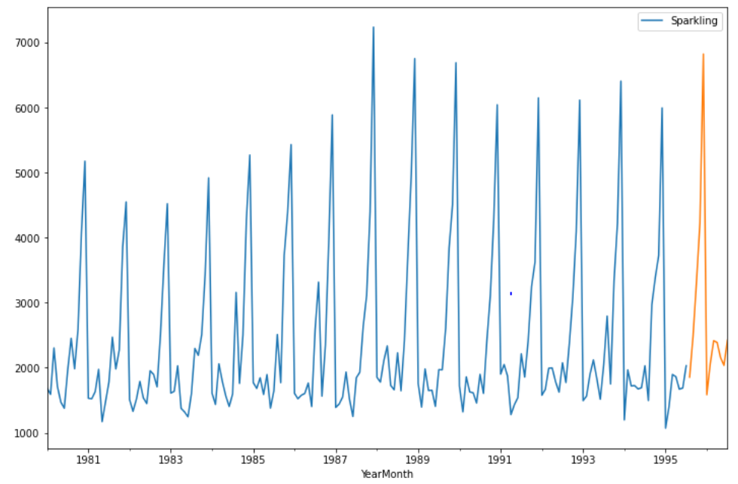

**Image 103: Prediction plot of final sparkling model**

One assumption that we have made over here while calculating the confidence bands is that the standard deviation of the forecast distribution is almost equal to the residual standard deviation.

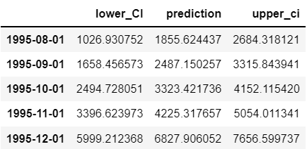

**Table 55: Confidence bands for final sparkling model**

We have calculated the upper and lower confidence bands at 95% confidence level, taking the multiplier to be 1.96 as we want to plot with respect to 95% confidence intervals.

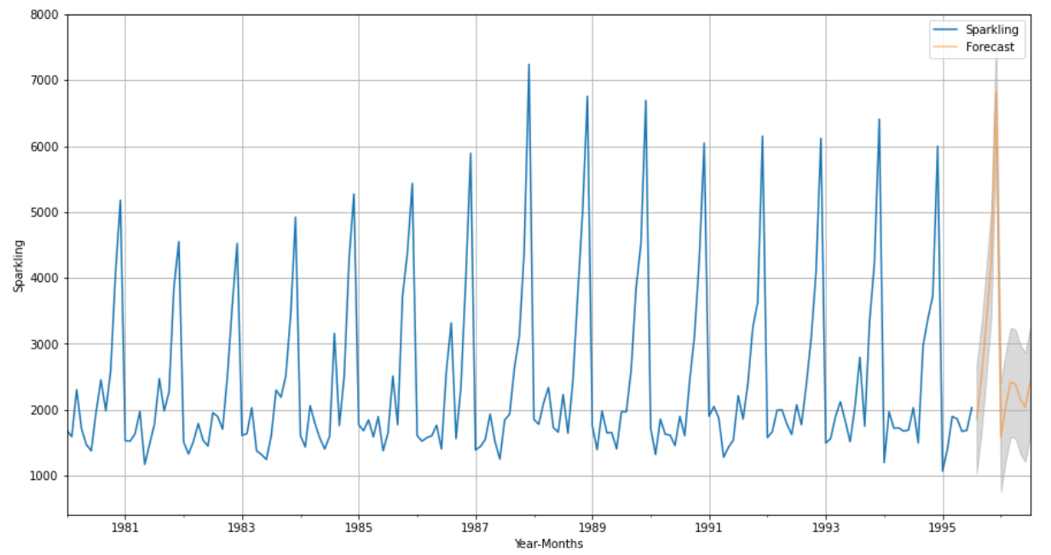

**Image 104: Forecasting plot of final sparkling model**

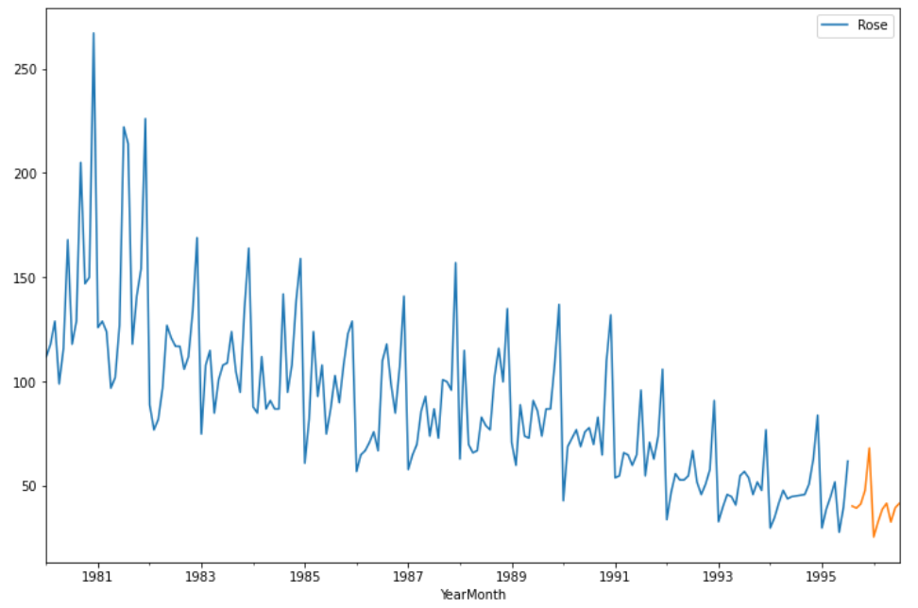

**Image 105: Prediction plot of final rose model**

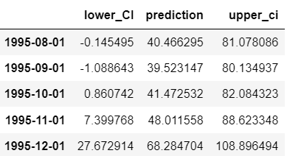

**Table 56: Confidence bands for final rose model**

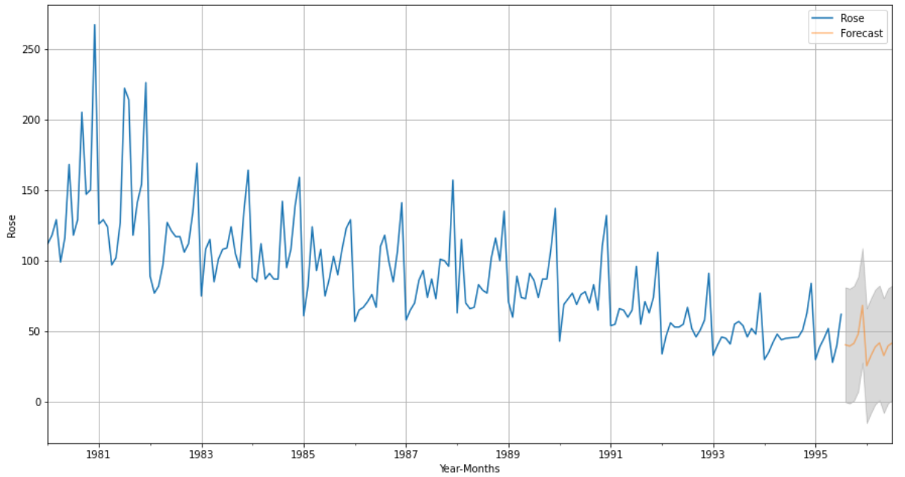

**Image 106: Forecasting plot of final rose model**

**Q 10. Comment on the model thus built and report your findings and suggest the measures that the company should be taking for future sales.**

The final model selected is the triple exponential smoothing model for both sparkling and rose datasets as it shows the lowest error values out of all the models built. The model is able to predict the expected behaviour of the sparkling and rose wine sales in the upcoming 12 months. Trend and seasonality are captured quite well by the model.

Findings and suggestions -

* The sparkling wine will be able to attain peak sales in the coming year as observed in the late 80’s, hence it can be concluded that the company is implementing correct strategies to improve sales.
* The sparkling wine sales only obtains highest sales in a particular month but remains moderate in the entire year. The company should look to offer discounts or coupons in those months where sales are below average.
* Rose wine sales are predicted to further decline in the next year which indicates that the company is unable to attract enough customers to purchase this wine or rather losing existing customers who may be looking at alternative options.
* Rose wine sales are contributing to the loss of the company which needs to be rectified by either totally eliminating the product or changing promotional strategies to bring in considerable profit.
* The company should ensure that the demand-supply chain is maintained which can otherwise lead to loss of reputation.
* The current model provides a short-term prediction but long-term prediction would make things clearer and company can plan accordingly.